Xerte Online Toolkits



Installation Guide

Pat Lockley, December 2009

Contents

Introduction 3

Installing Xerte Online Toolkits with XAMPP on a Local Machine 4

Using XAMPP 4

A local install with an existing version of XAMPP 15

As a local install, but on a Linux or Mac Operating System 15

What will and won’t work on local installs 18

Properties tab 18

Folder properties tab 18

Workspace Properties tab 18

Management.php 18

Installing Xerte Online Toolkits on a Web Server 19

Pre-installation server checks 19

Folder Permissions 19

Further Installation Guidance 19

Authentication in Xerte Online Toolkits 32

Demo.txt 32

Integration.txt 32

Webctlink.txt 32

Switch.txt 32

Running Xerte Online Toolkits with Authentication from Moodle 33

Frequently Asked Questions 34

Site Management 36

Using Management.php 36

The Main Panel: Site 36

Controlling What Templates Are Available: Central templates 38

Manager User Accounts: Users 40

Managing User Projects: Users templates 41

Tracing Site Activity: Errors 43

Setting New Security Options: Play Security 44

RSS Options: Licenses 46

RSS Options: Feeds 47

Introduction  
Xerte Online Toolkits is a suite of tools for the creation of elearning materials. It is intended for installation on an organisation’s web server, where the full functionality can be used.

It is possible to install Xerte Online Toolkits on a standalone PC or laptop (on any operating system that supports PHP and MySQL), using third party software to provide the functionality normally provided by a web server (XAMPP). It is also possible to run Xerte Online Toolkits from a memory stick.

Installing Xerte Online Toolkits with XAMPP on a Local Machine

## Using XAMPP

This is the simplest way to get the software up and turning on a standalone machine. You will need to download and install XAMPP, download and install Xerte Online Toolkits, and then run the setup utility provided.

First, visit http://www.apachefriends.org

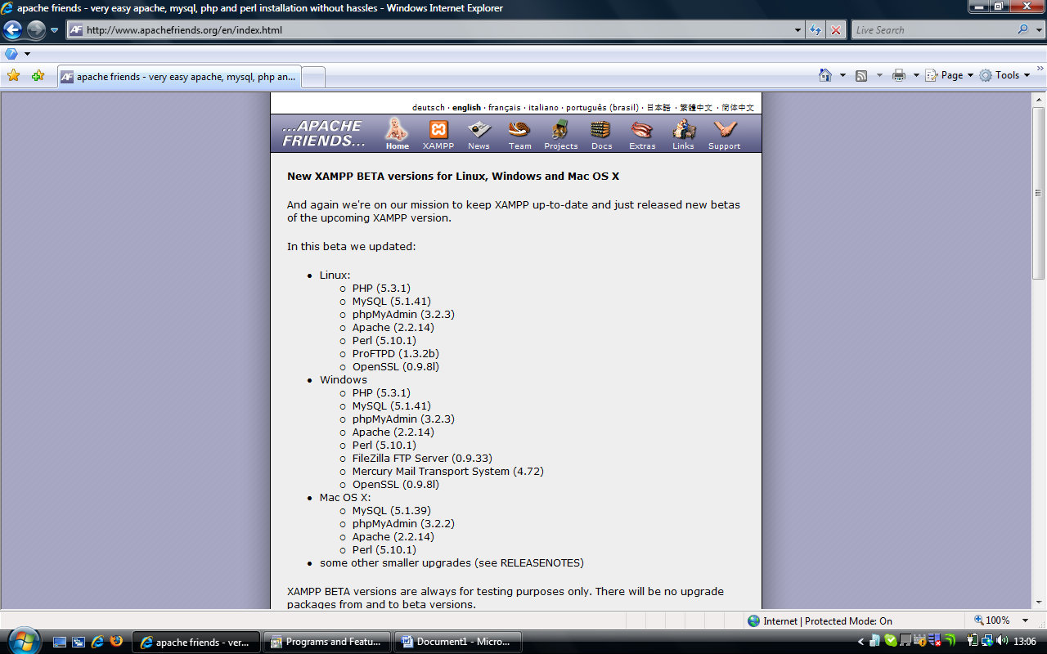

Click on the XAMPP icon on the top bar, and the XAMPP version will load. This guidance now assumes you are installing Windows XAMPP.

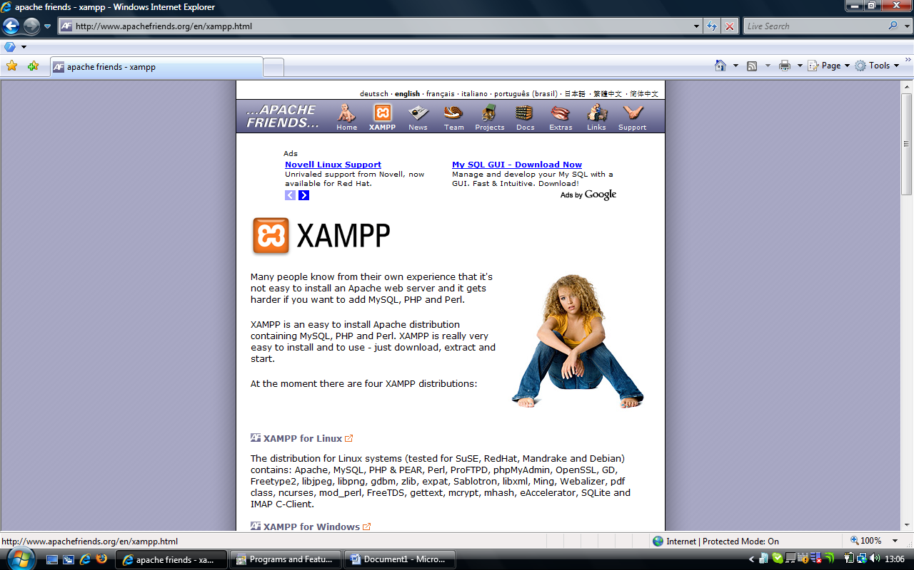

Scroll Down this page until you find the version you would like to download.

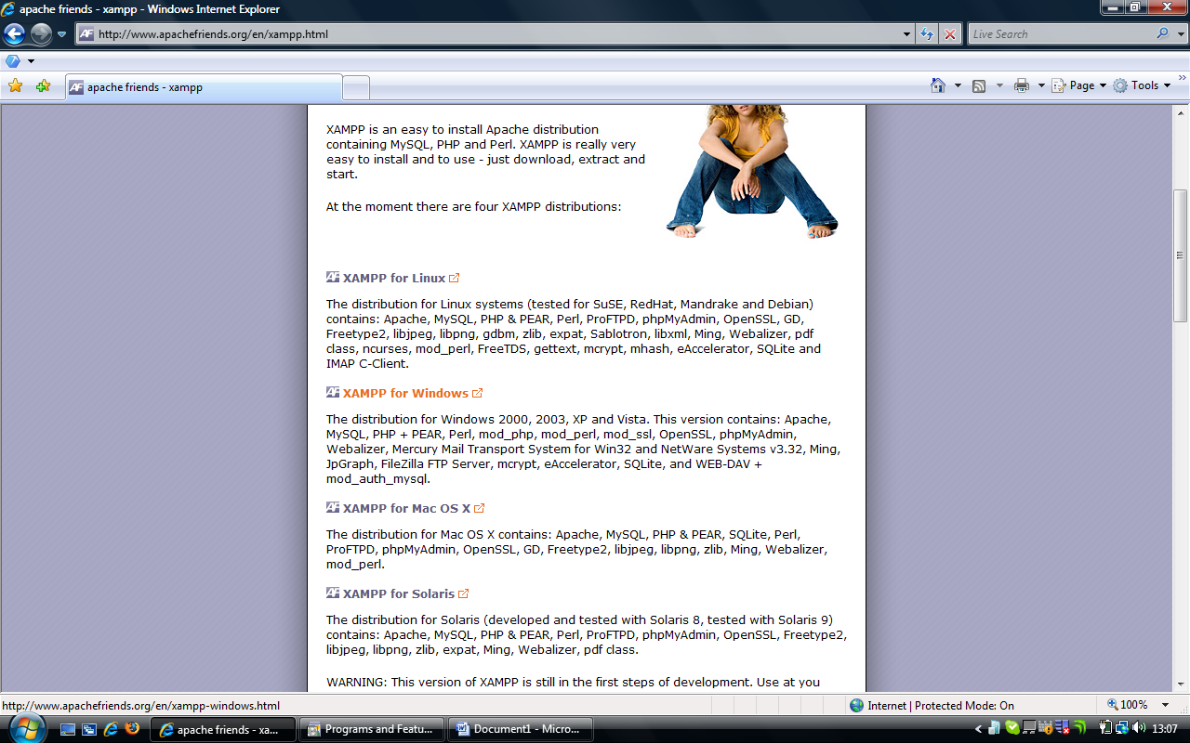

The windows version can be found here (XP/ VISTA and Windows 7), and then the XAMPP for Windows page will load

If you can’t install a windows version, the process is approximately the same, the only direct difference is that the XAMPP option is PC only. Non-PC users should follow the full path.

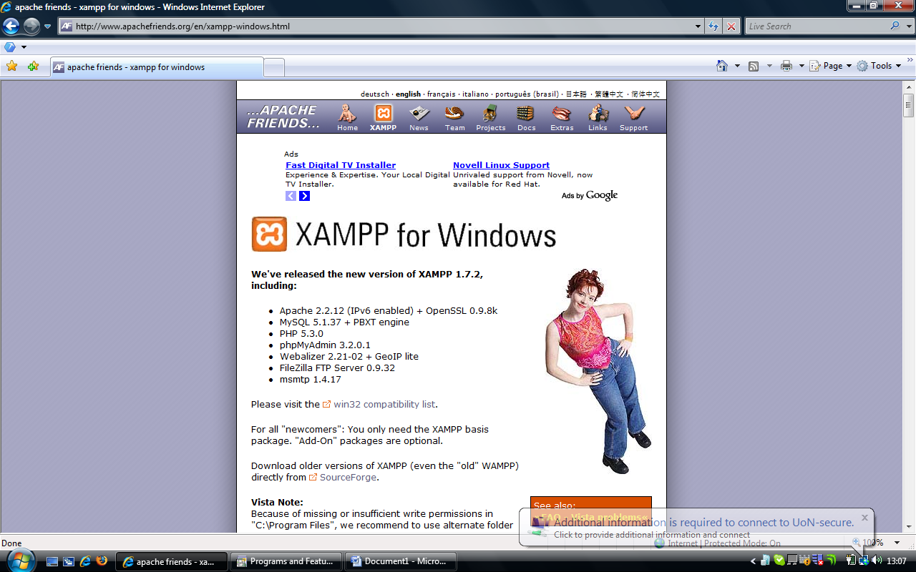

Scroll down the page.

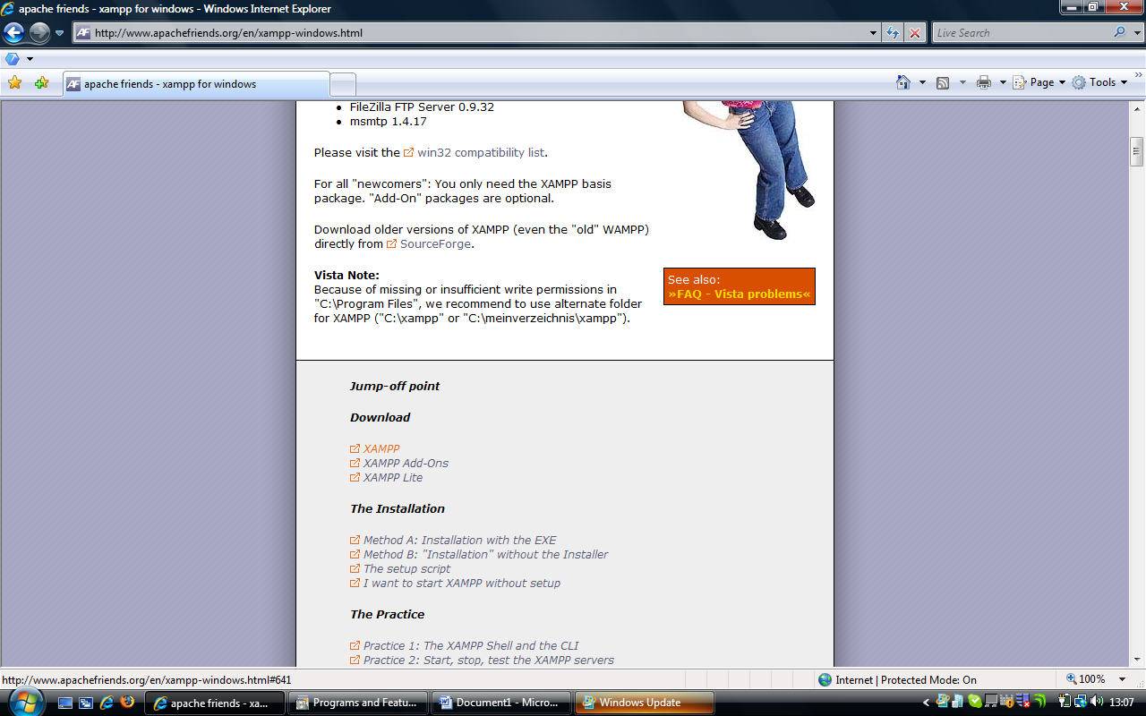

Select XAMPP here, the page will then jump down, and select self-extracting archive

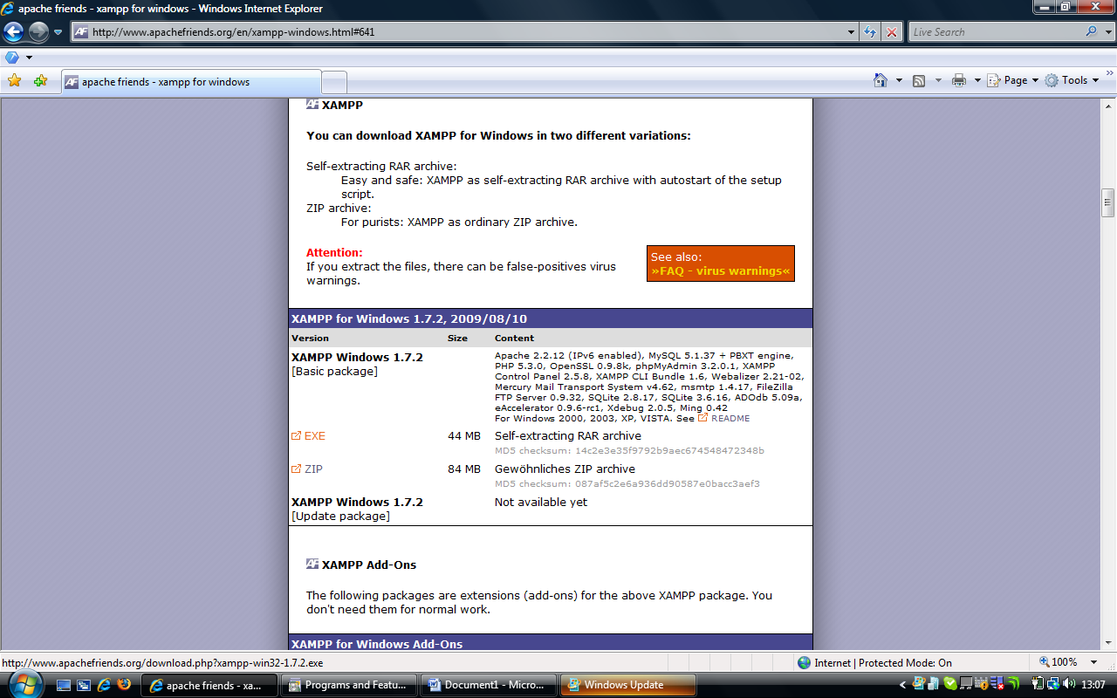

You will then be taken to the download page. Once you get here, the download should start automatically. If not, left click on “direct link”.

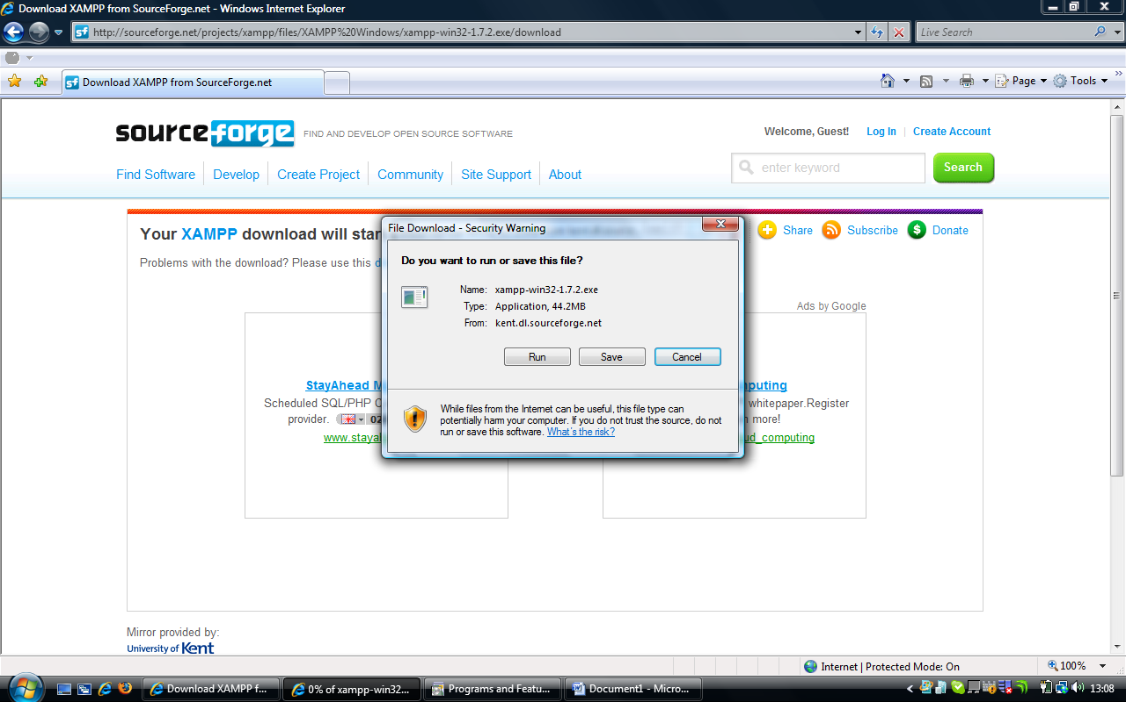

The download should now start as shown above. Left click on run.

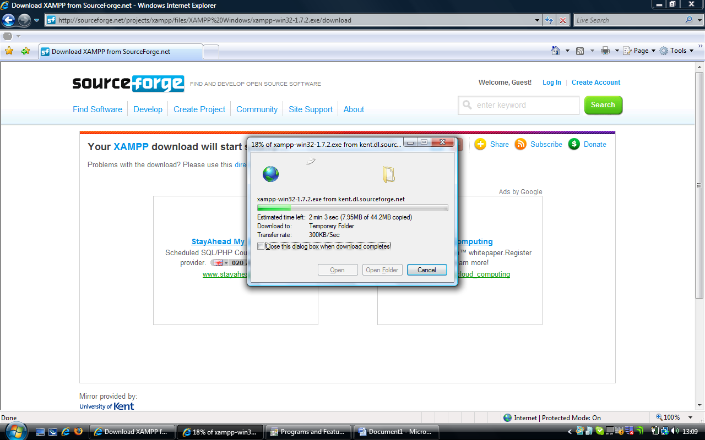

The download will now progress.

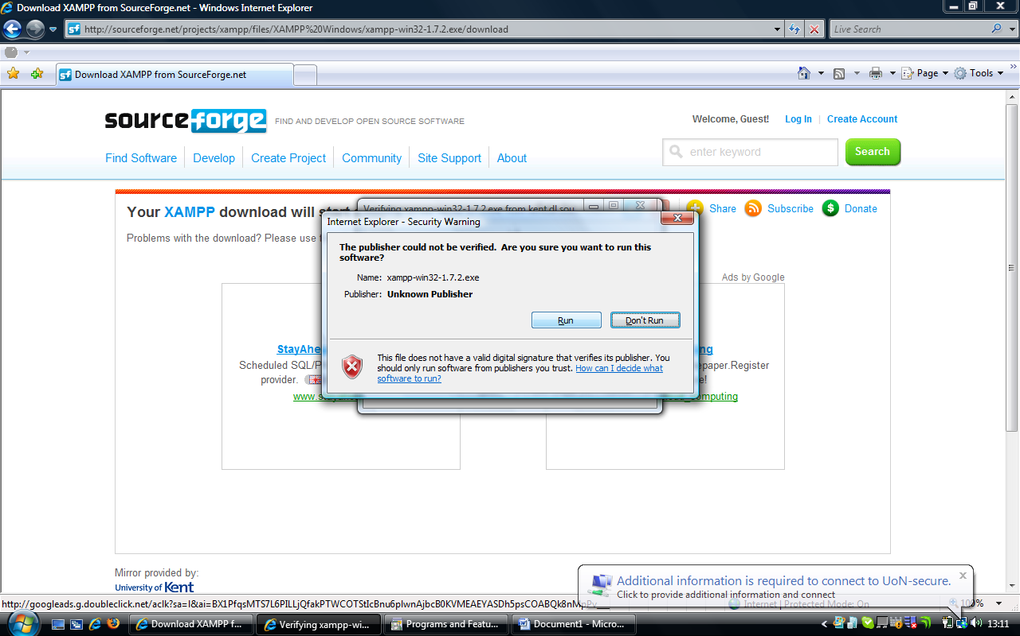

Once the download has finished, left click on run

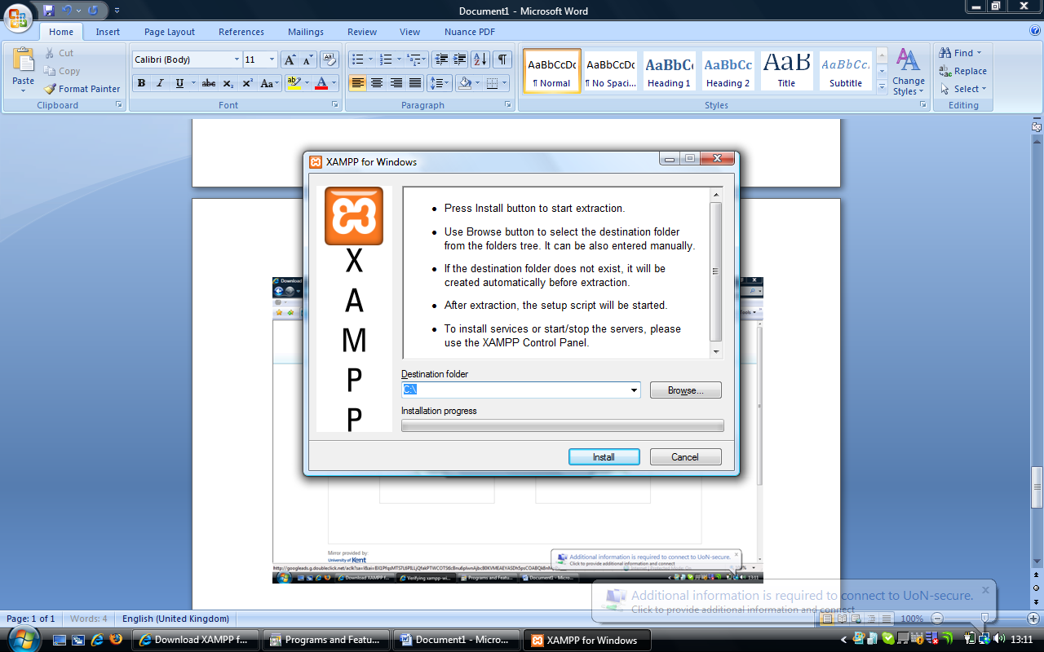

Now XAMPP has started to download, choose “C:\” as the destination folder.

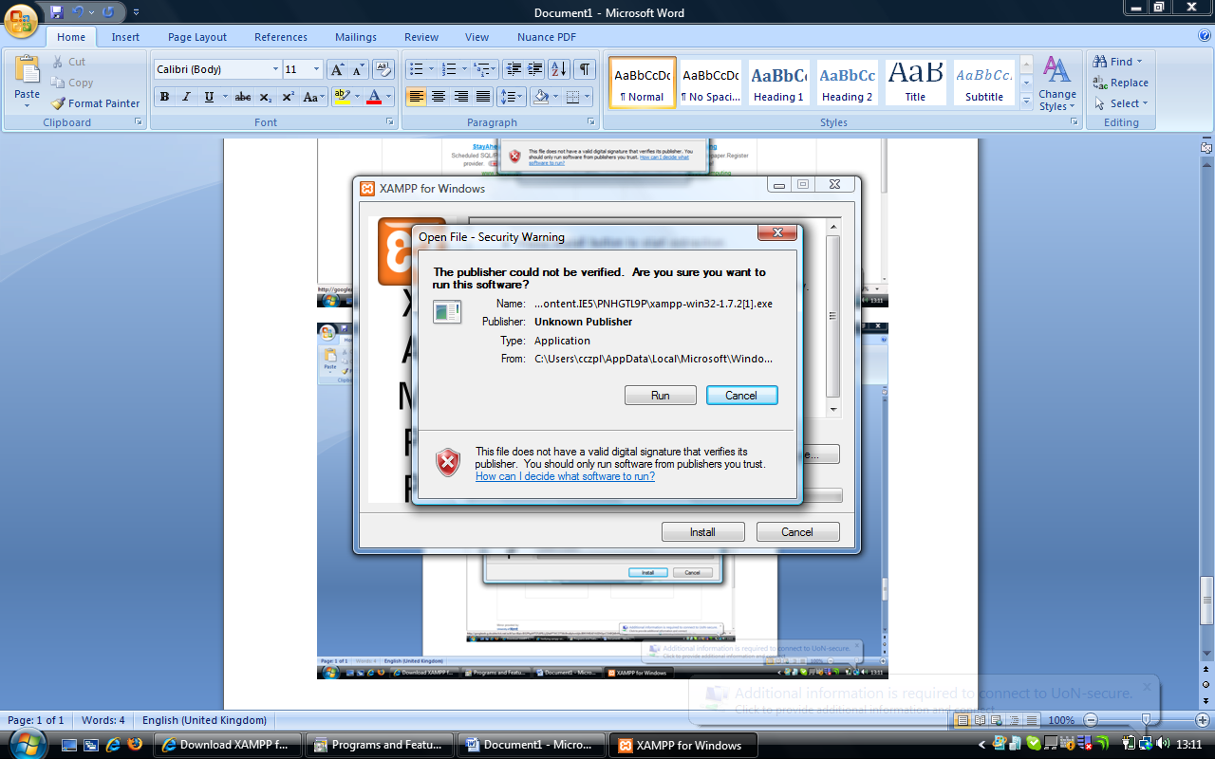

If you receive this message click on run. You may need administrator rights on this PC to install software. If you are unsure please contact your IT Support.

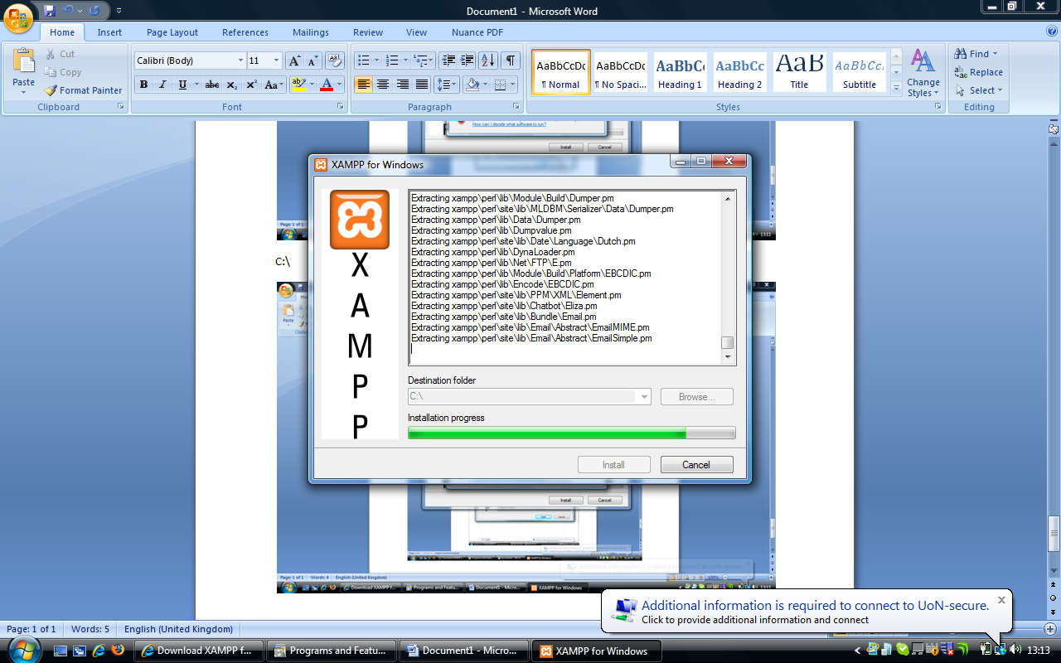

XAMPP will then install

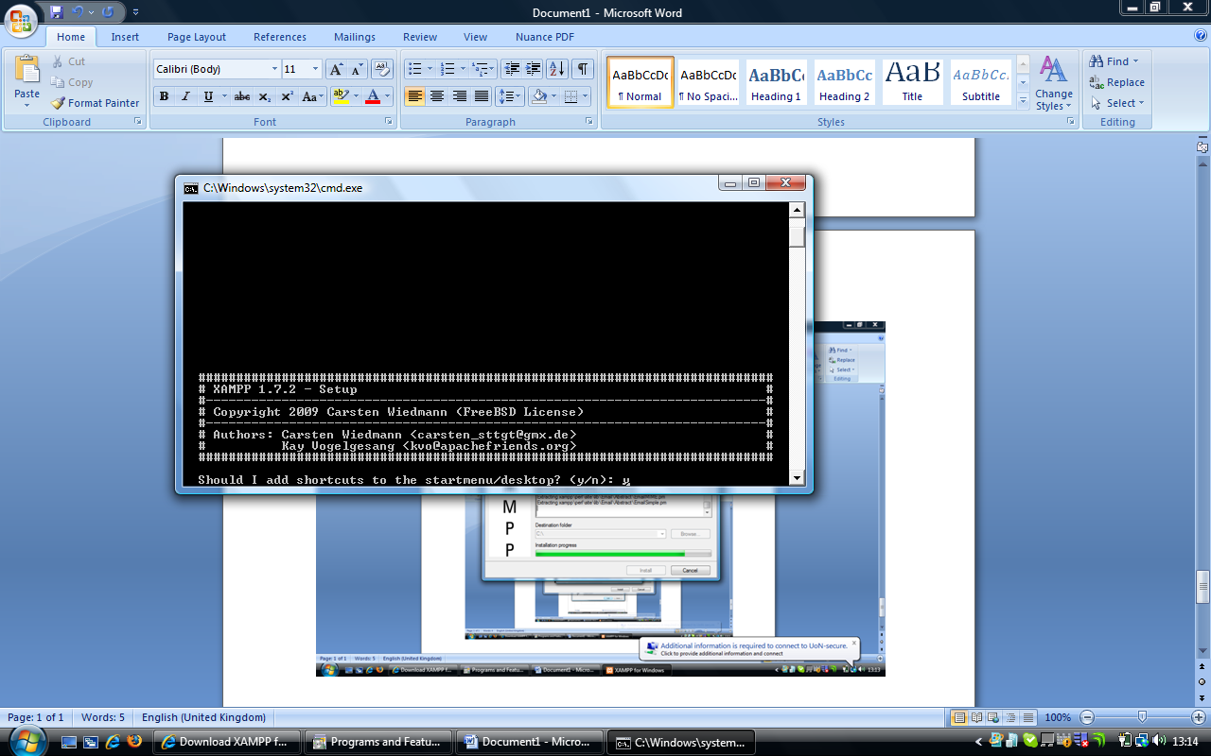

Once XAMPP is finished it will try to configure itself according to your preferences.

At the prompt, “To add shortcuts” press y then return

At the prompt “Should I proceed” press y then return

At the “drive letters” prompt, press y then return

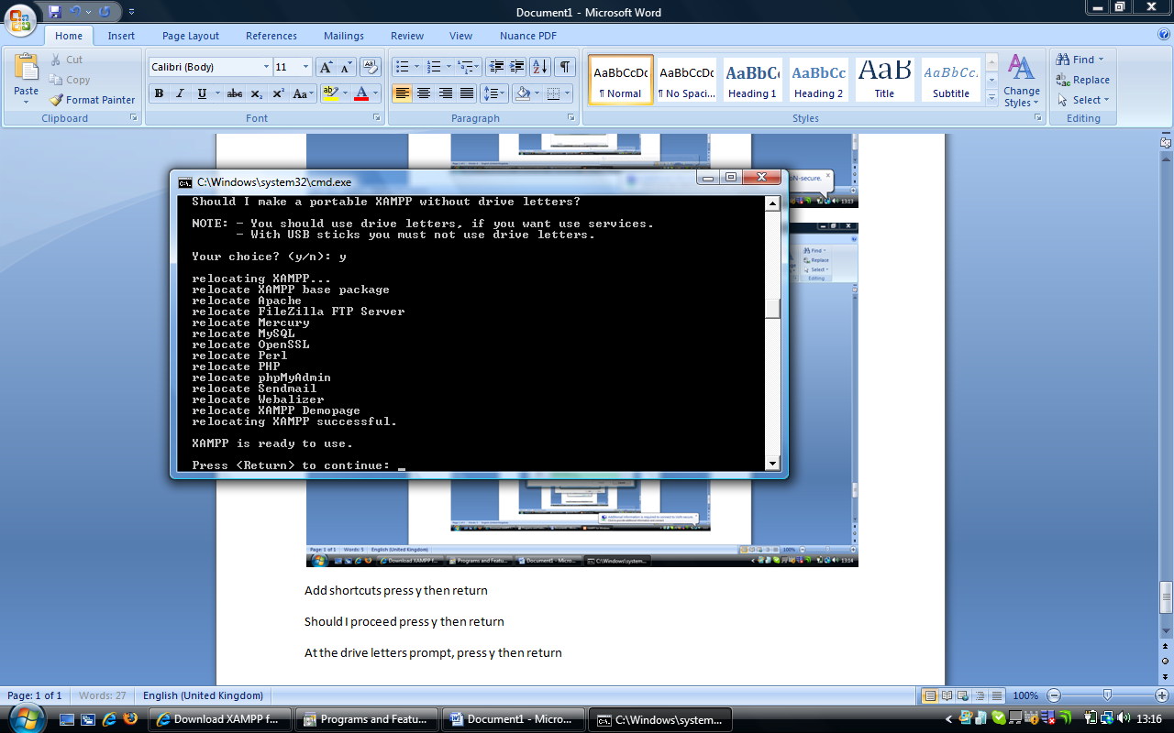

On this screen, press return

Then wait for the question about locations, then press return again

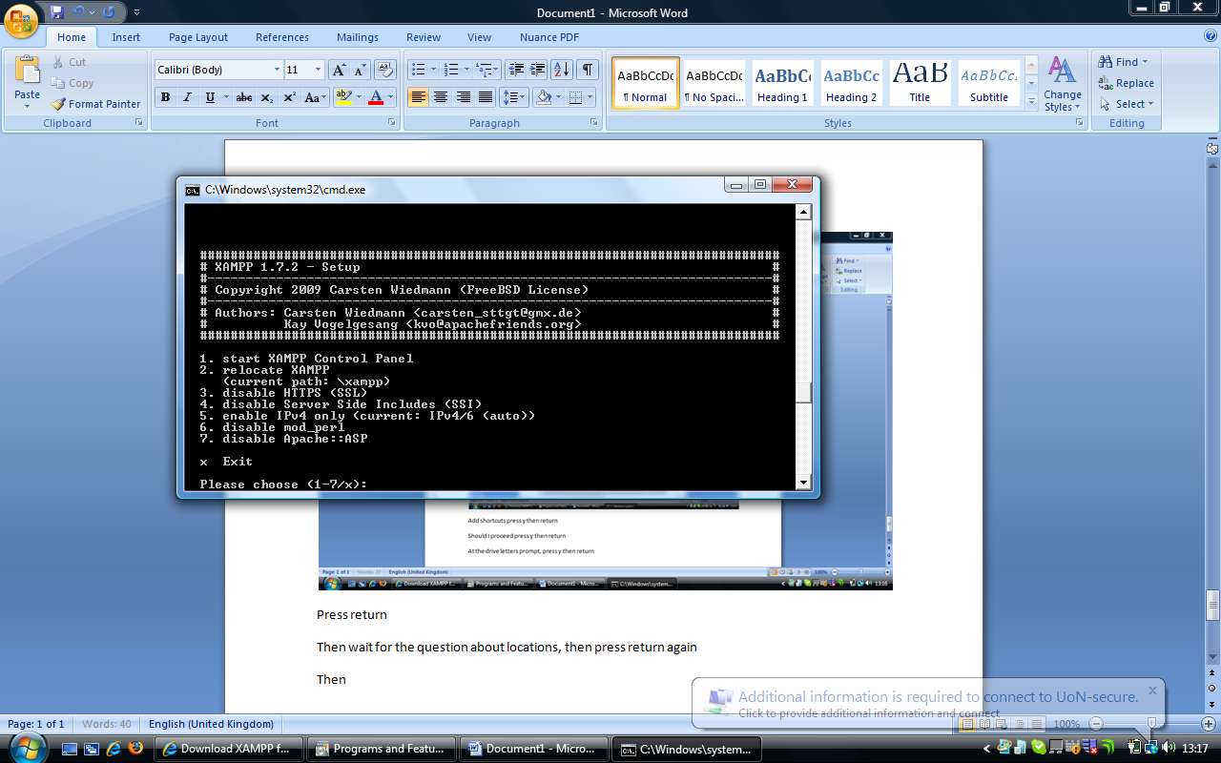

Then press 1, then press return, which will start the XAMPP Control Panel, which will appear as so

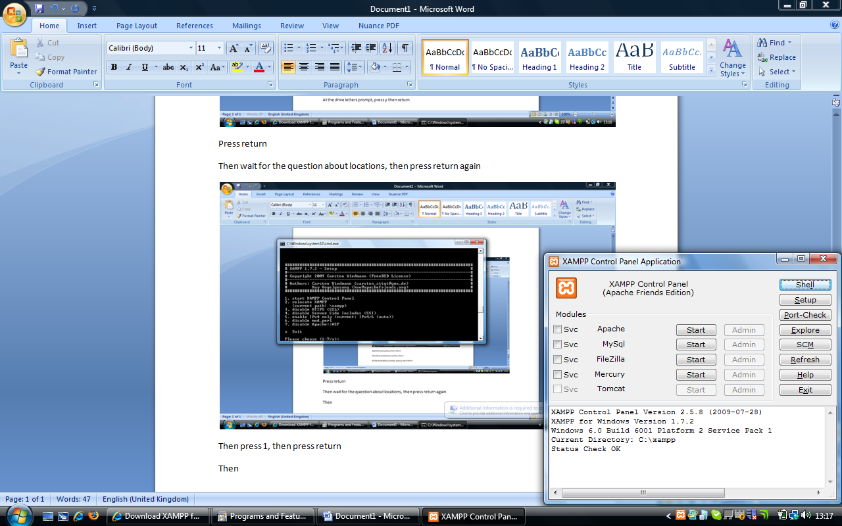

Then click on the start button next to apache

Then click on the start button next to mysql

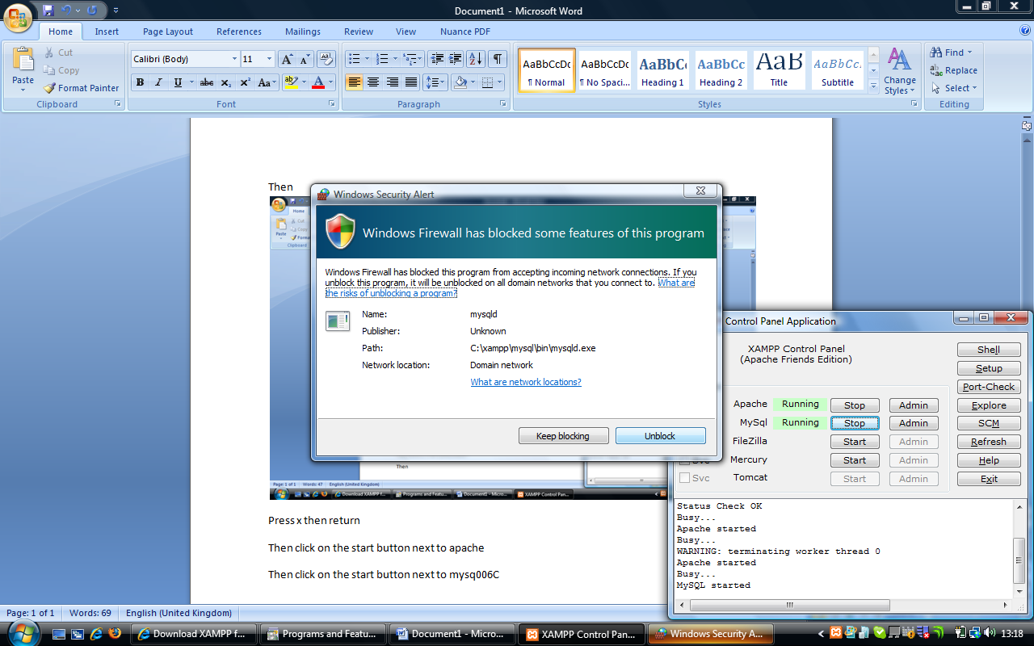

You may get messages like this, click on unblock.

Finally, click back in the black window, and press x then return

Then go to the Xerte website (<http://www.nottingham.ac.uk/xerte>) and select Xerte On-line Toolkits from the left hand side. This will then offer you the chance to download the zip.

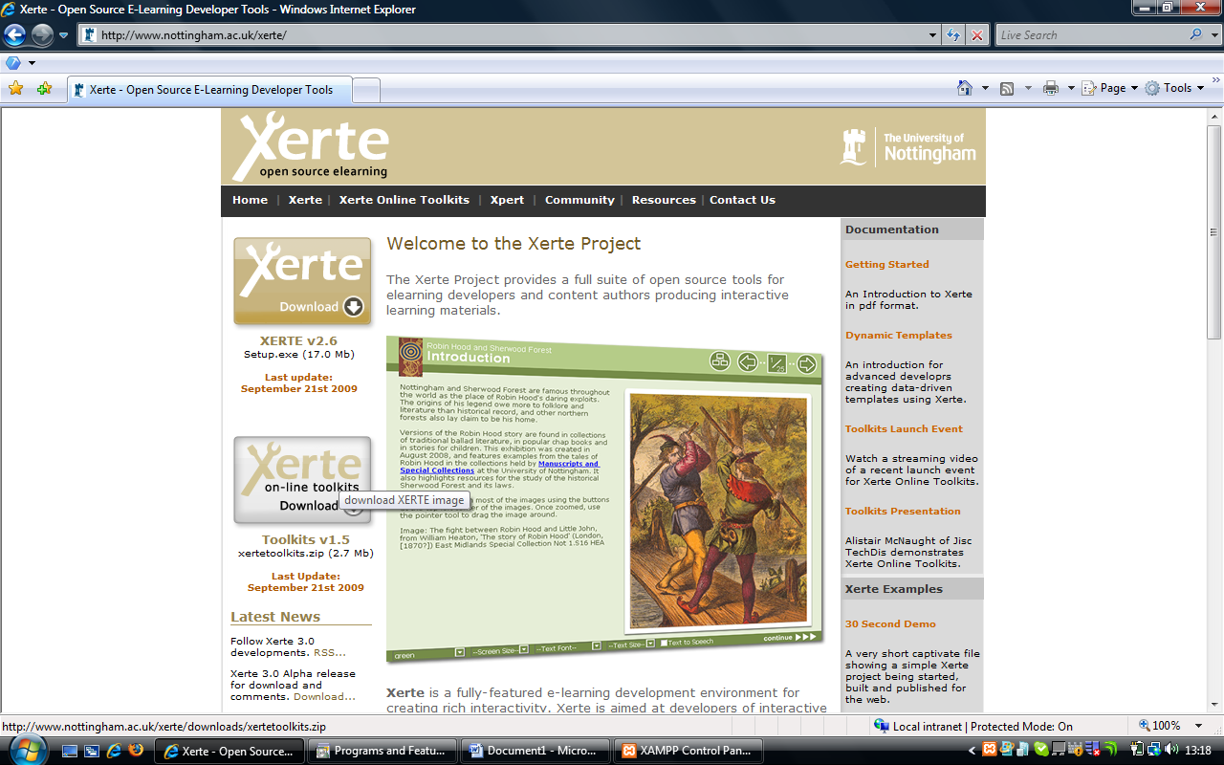

Accept the download by clicking on “save”, then opt to save it to “c:\xampp\htdocs\xertetoolkits\”

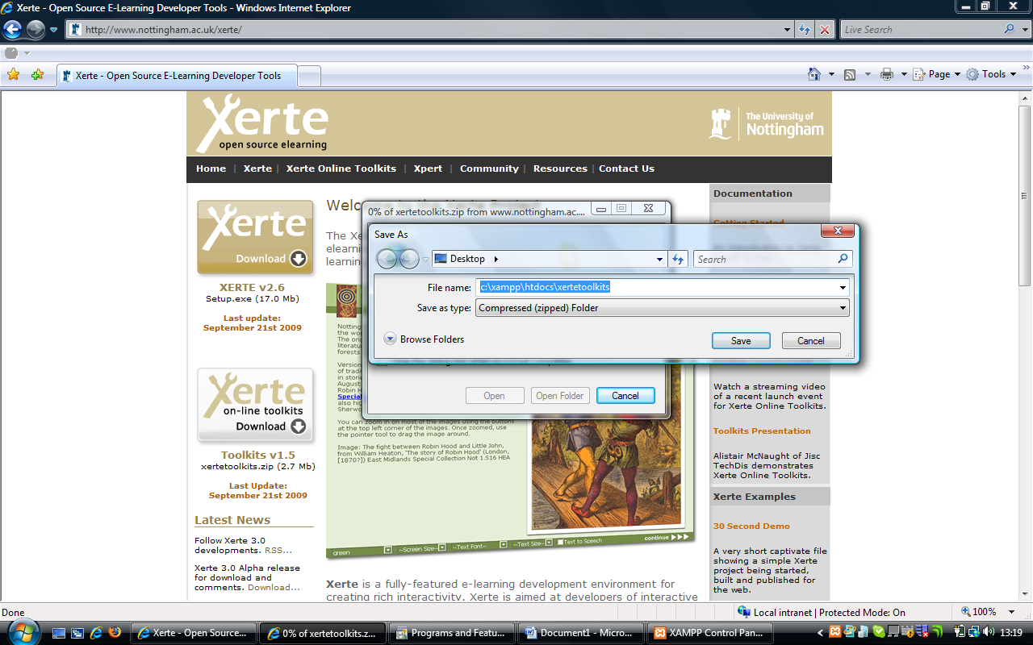

Once the download has finished, navigate to c:\xampp\htdocs\xertetoolkits\

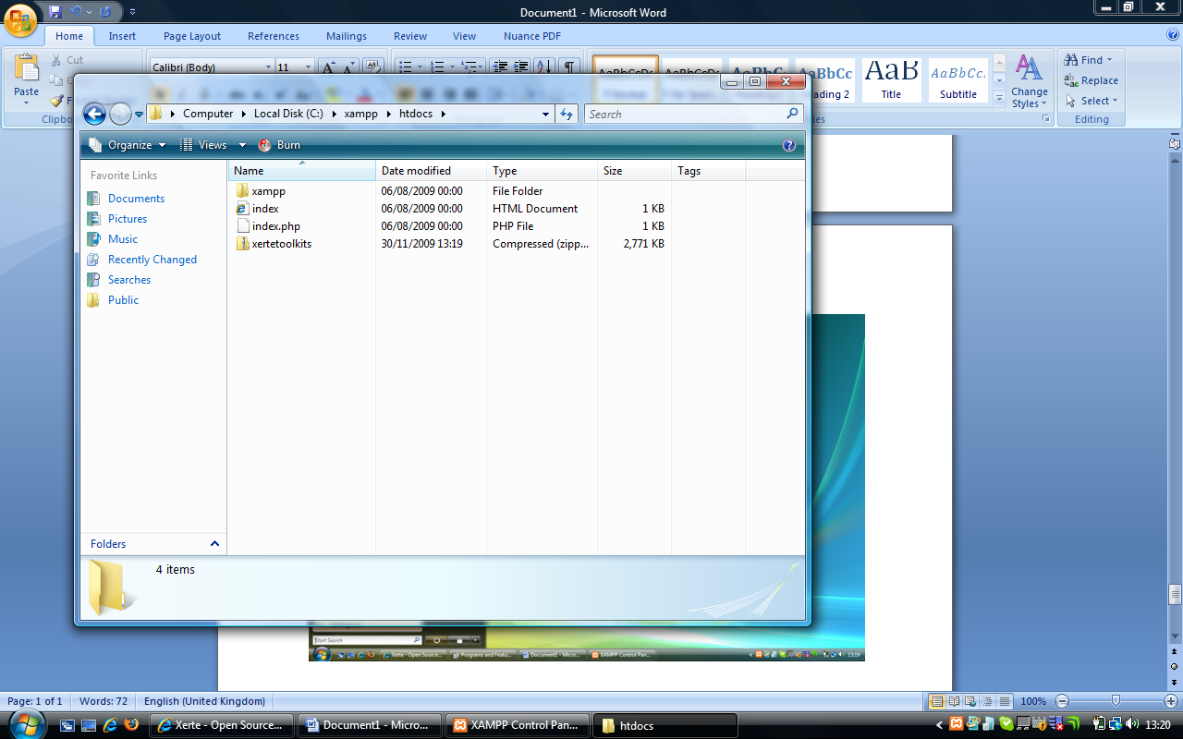

Right click on the zip file, and select “Extract all”

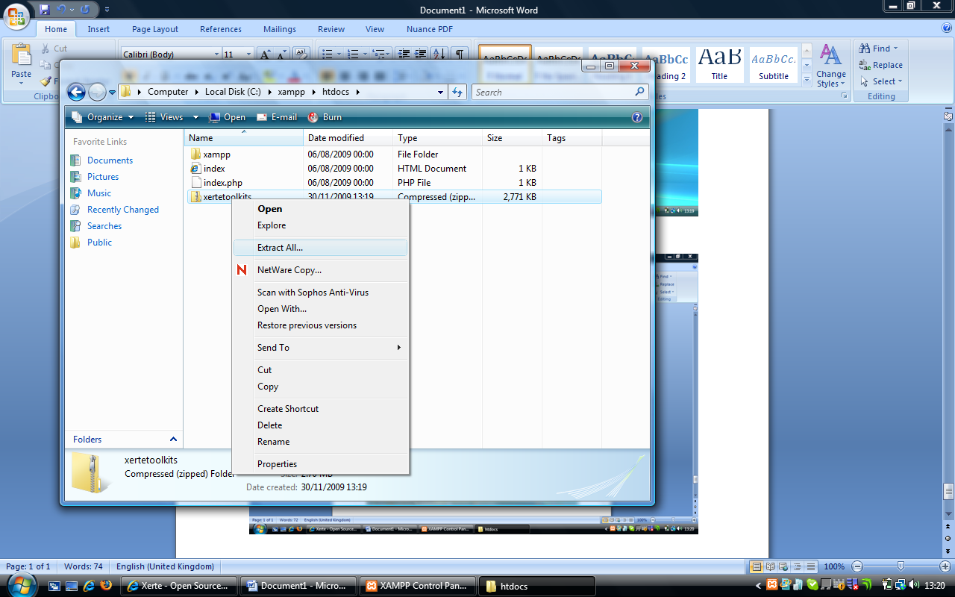

When prompted, make sure the value shown below is “c:\xampp\htdocs\xertetoolkits”

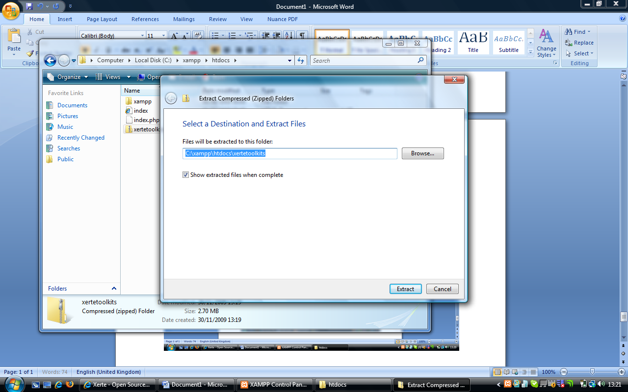

The extraction will then run, and when it is finished you should see a screen like below.

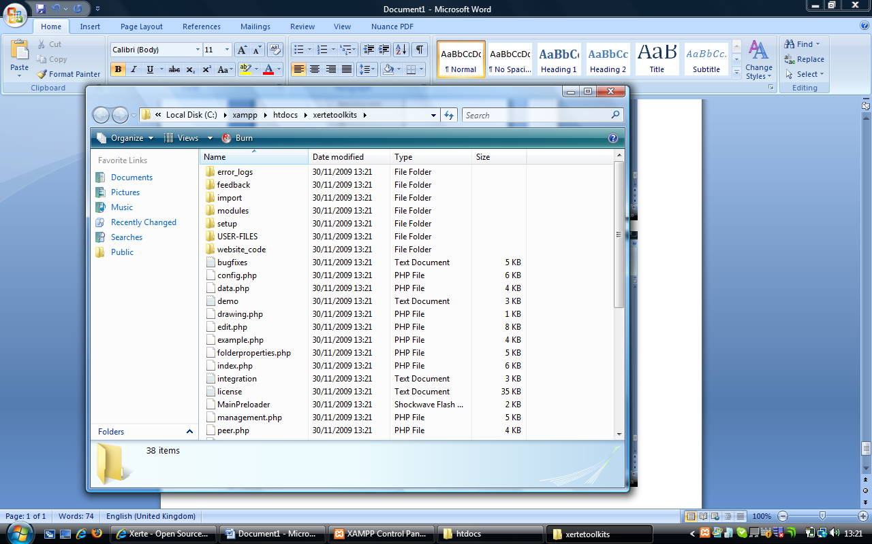

Then start a web browser, and then visit this address

[**http://localhost/xertetoolkits/setup/**](http://localhost/xertetoolkits/setup/)

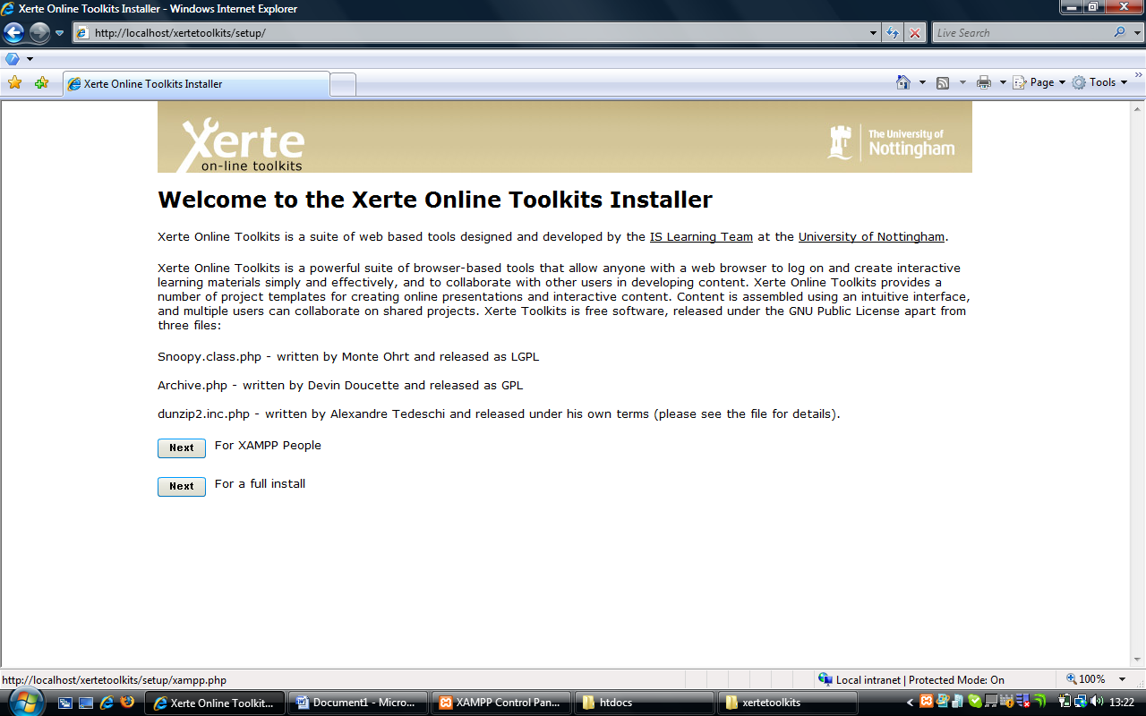

You should see this screen, and you should click on XAMPP

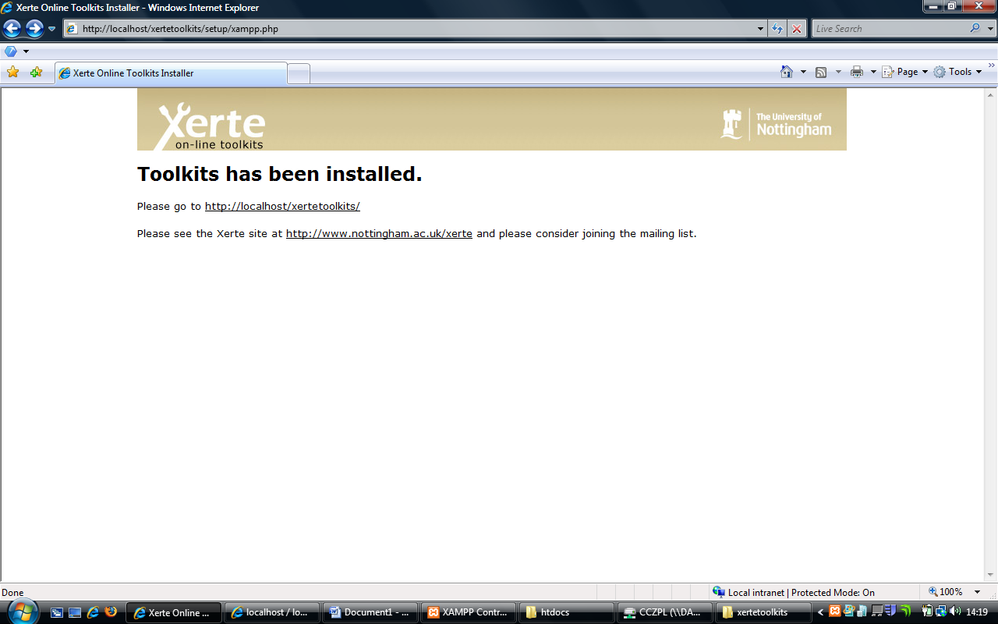

You should then receive this screen, so click on the first link, and you should see the screen below.

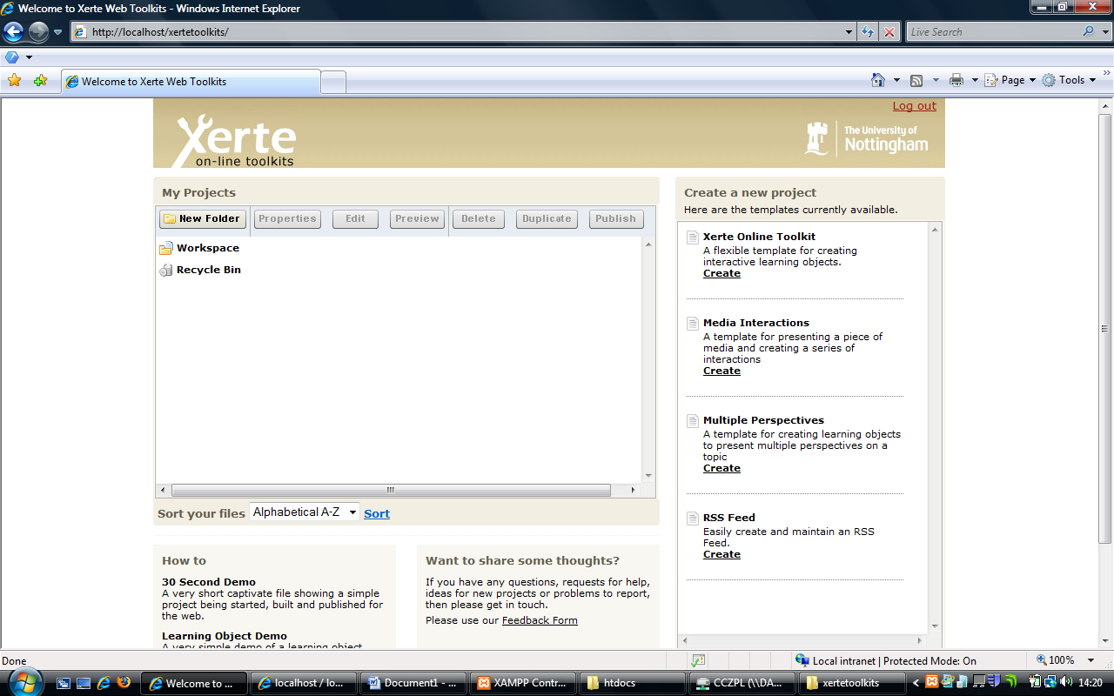

A local install with an existing version of XAMPPIf you installed XAMPP into C:\xampp\htdocs, and have not altered your MYSQL root password then you can proceed as above, as effectively your install is the same.

If you have altered these settings, then you have to proceed as if this was a full install and take the non-xampp route.

As a local install, but on a Linux or Mac Operating SystemIf you don’t have access to a windows PC to install your software on, then you have to proceed as if this was a full install and take the non-xampp route. The final page has a lot of variables, but people using it locally on a standalone unit, please do the following.

Start by downloading the zip. Go to the Xerte website (<http://www.nottingham.ac.uk/xerte>) and select Xerte On-line Toolkits from the left hand side. This will then offer you the chance to download the zip.



Accept the download by clicking on “save”.



Once the download has finished, extract the zip file’s contents to a temporary folder. Then make a new folder on your webserver and then take the files / folders and place them in that folder on the file system that acts as your webserver. For XAMPP Installs, this is usually “htdocs”.

Once you have down this, open a new web browser and navigate to <http://(your> web host)/the folder you created earlier/setup. Your webhost should be http://localhost/

You should see this screen, click on full

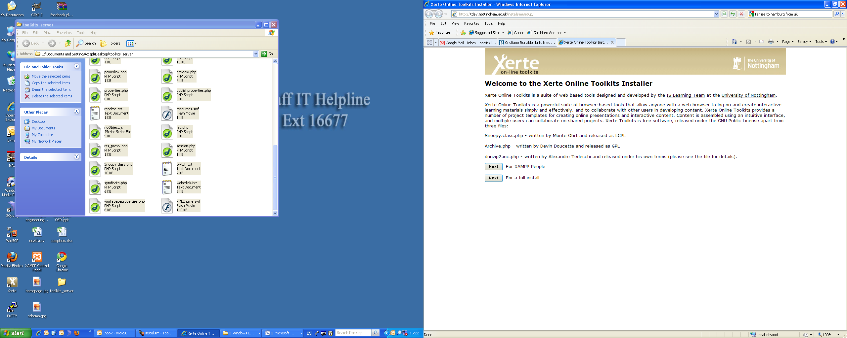

You will then see this screen

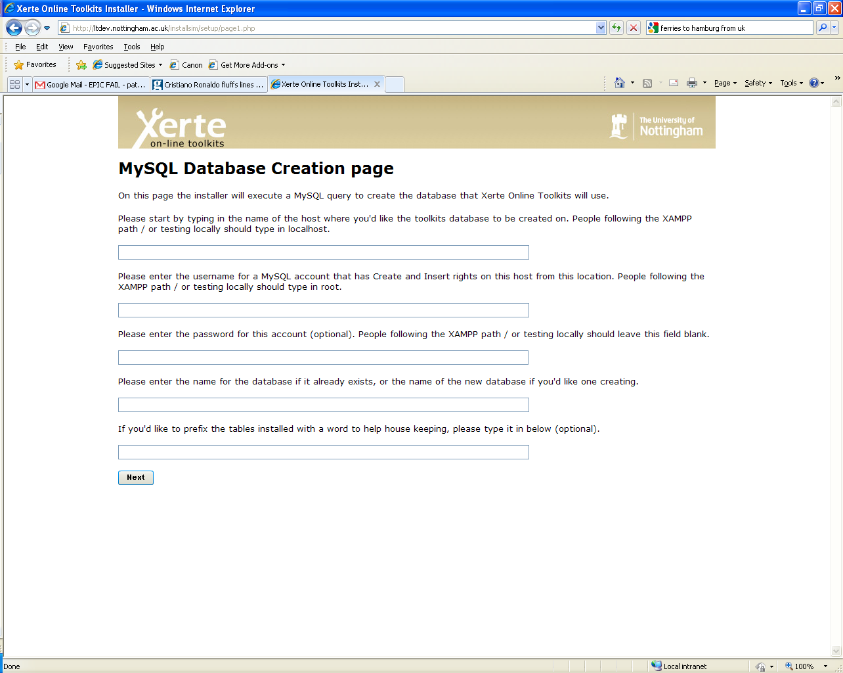

**1**

**2**

**3**

**4**

**5**

**In Box 1** – Type in localhost

**In Box 2** – Type in root

**In Box 3** – Leave this empty

**In Box 4** – Type in Toolkits

**In Box 5** – Leave this empty

When you have entered these values click “Next”. Clicking next will attempt to create the database, if this fails it will give you error messages on the next page.

On this page, you will enter an account which the site will use to connect to the database. Xampp people can use root as the account name, and leave the password blank.

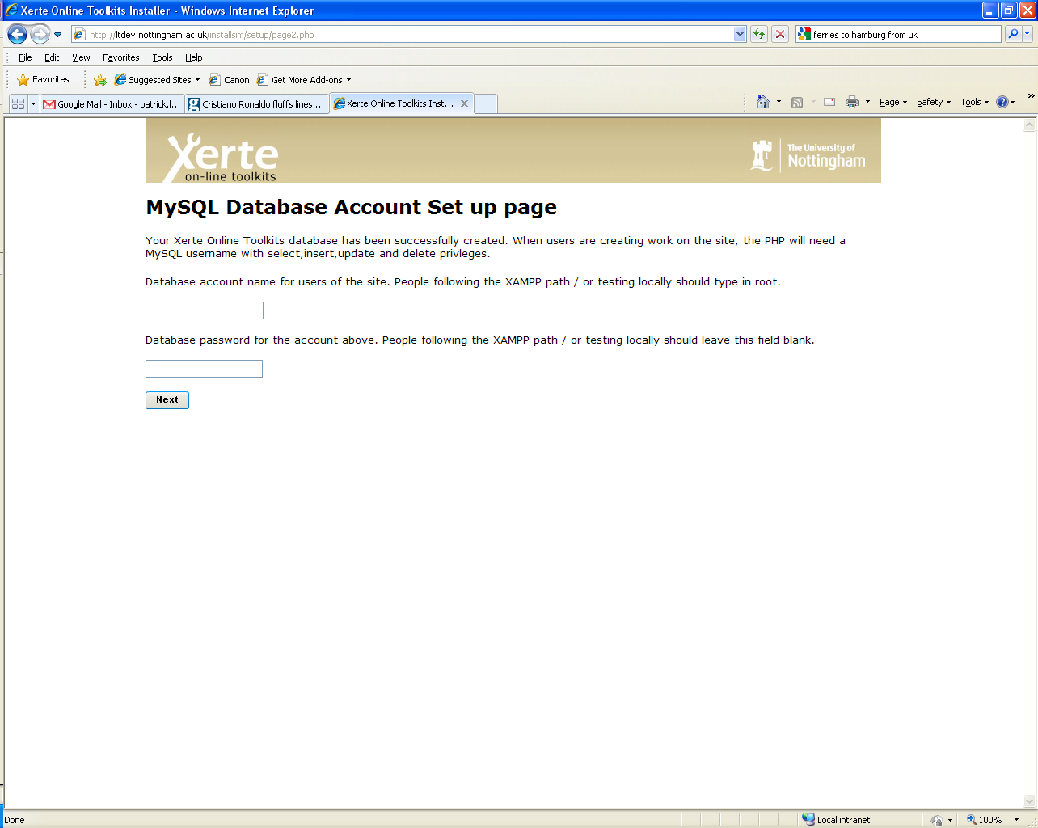

**1**

**2**

**In Box 1** – Put the name of the MySQL account you wish to use

**In Box 2** – Put the password for this account

When happy with these values, please click next. This will take you to page 3 of the installer.

Ignore all the values on this page, and scroll down and click submit query. All being well, your site will now install.

People who have not followed the XAMPP path will now need to do the following.

1) Go to the root folder of your site

2) Rename index.php to be index.old

3) Rename demo.php to be index.php

Then you can go to <http://localhost/toolkits> and use your site. Mac or Linux users may find that localhost is suffixed with a port number and so the link presented there will not work.

## What will and won’t work on local installs

### Properties tab

Access – Password protected will not work, Public will not provide any great benefit as the link will only work on your computer.

Shared Settings – This will not work as a local install only has one user.

RSS – Will work, but the links are not distributable as the link will only work on your computer.

Open Content – Will work, but the links are not distributable as the link will only work on your computer.

Peer Review – Will work as a link, but the email function will not, and the link should not be distrubted as the link will only work on your computer.

XML – Will work, but the links are not distributable as the link will only work on your computer.

### Folder properties tab

RSS feed for this folder - Will work, but the links are not distributable as the link will only work on your computer.

### Workspace Properties tab

My details – These will not reflect who you are

My Feeds – Will work, but the links are not distributable as as the link will only work on your computer.

### Management.php

As the default XAMPP Install does not set a password, this will not work. If you are confident using phymyadmin (usually <http://localhost/phpmyadmin/>) then you could use this to add a password and username to the admin_password and admin_username values. Once set these can be used to log into management.php

# Installing Xerte Online Toolkits on a Web Server

Pre-installation server checksPlease note the following technical requirements for the site. These are the basic minimum requirements. The site and / or installer will not work if these are not available.

1. A PHP Server running version 4 or above (Xerte Online Toolkits was developed on php 4.3.9 and on php 5.2.5.).
2. A MYSQL Install (Xerte Online Toolkits was developed on ver 14.12 Distrib 5.05.51a for Win32. We haven't tested this with other versions, or on other database systems) , there is currently no database abstraction layer, you will need MYSQL.
3. All of the above can come from a single WAMP or LAMP installation, such as those available as part of [XAMPP Project](http://www.apachefriends.org/)
4. Although not critical, Xerte Online Toolkits uses PHP mail functions for parts of its code. You can remove these manually from the code should you so wish.
5. Xerte Online Toolkits has been build around LDAP authentication - you can however not use this is you prefer. If you do not use LDAP authentication**,** then you should aim to use another service to authenticate, the code has one small scale authentication option, but this is definitely not enterprise level.

Do not proceed with the installer unless you have these as the installer will fail, or the system will not work for you at all.

Folder PermissionsThe are some settings which must be in place before starting the installer. You should set the file permissions on the following folders as the page specifies.

1. The root folder for this install must be set to chmod 0777 / Full write access.
2. The setup folder for this install must be set to chmod 0777 / Full write access.
3. The user files folder for this install must be set to chmod 0777 / Full write access.
4. The error log folder for this install must be set to chmod 0777 / Full write access.
5. The import folder for this install must be set to chmod 0777 / Full write access.

Once the installer has finished, you can set the folder permissions to your own preferences - except for USER-FILES, error_logs and import, to which the web server will still need write / read and delete access.

## Installing on IIS

This guide to installing toolkits on ISS was contributed by Peter Hartley.

* The server should be running MySQL and PHP - the usual set up for something like Moodle should suffice.
* Create a database on the server using MySQL called Xerte
* Create a user called xerte and give them all schema privileges to the database, choose a suitable password
* Create a folder in the server web site called xertetoolkits
* Give Everyone modify access rights to this folder
* In IIS Manager right click on the folder and go to properties
  + In Directory Security make the folder Anonymous Access
  + In HTTP headers select MIME Types and add
    - Extension: .rlm and MIMEtype: text/plain
    - Extension: .rlo and MIMEtype: text/plain
    - Extension: .rlt and MIMEtype: text/plain
* Download the Xerte Online Toolkits from <http://www.nottingham.ac.uk/toolkits/>
* Extract the zip file to another folder
* Rename the file index.php as index1.php
* Rename the file switch.txt as index.php
* Look at the index.php file and find the line which says switch($_POST["login"]){. Below that line is a set of users and passwords, you will need to use one of these for testing.
* Now copy all the files from the extracted folder into the xerte folder on the web site
* On the server itself load a web browser and run <http://(yourserver)/xertetoolkits/setup><http://%28yourserver%29/xertetoolkits/setup> and click on 'For a full install'.
* On Page 1 enter the following:
  + Please start by typing in the name of the host where you'd like the toolkits database to be created on. People following the XAMPP path / or testing locally should type in localhost. – localhost
  + Please enter the username for a MySQL account that has Create and Insert rights on this host from this location. People following the XAMPP path / or testing locally should type in root. - xerte as above
  + Please enter the password for this account (optional). People following the XAMPP path / or testing locally should leave this field blank. - xerte password as above
  + Please enter the name for the database if it already exists, or the name of the new database if you'd like one creating. - xerte as above
  + If you'd like to prefix the tables installed with a word to help house keeping, please type it in below (optional). - leave blank
* On Page 2 enter the following:
  + Database account name for users of the site. People following the XAMPP path / or testing locally should type in root. - xerte as above
  + Database password for the account above. People following the XAMPP path / or testing locally should leave this field blank. - xerte password as above
* On page 3 enter the following:  
      *   The site url is (This is the URL of the site - changing this will not change the URL) - <http://(yourserver)/xertetoolkits><http://%28yourserver%29/xertetoolkits>  
      *   The admin username is - xerteadmin  
      *   The admin password is - suitable password  
      *   Leave the rest to edit later
* The installation should now finish
* Leave the server and go to the web site on a local computer at <http://(yourserver)/xertetoolkits/management.php><http://%28yourserver%29/xertetoolkits/management.php> and logon as the xerteadmin. From here you can edit the details you missed out on page 3.
* Now logout and go to <http://(yourserver)/xertetoolkits/><http://%28yourserver%29/xertetoolkits/> using the user and password you noted from the switch.txt which you renamed index.php.
* Test Xerte to see if it works.
* Add more users to index.php for testing or change the users already there.
* To use LDAP edit the LDAP settings, rename index.php as switch.txt and rename index1.php as index.php. (This process can be reversed).

## Further Installation Guidance

Use your PHP info page (one comes in the setup folder) to find the 'Configuration File' (look on the first part of the php info page for the text 'Configuration File' - the use this path to find the file. Make a copy of it before you start. You can edit this file in notepad, or any text editor. People following the XAMPP path should find that they do not need to make any of these changes to make their system work. Most servers will also have the majority of these settings already in place

## 

**The PHP File uploads setting**

* Look in the Ini file for "file_uploads =" and set the value to be On
* Look in the Ini file for "upload_tmp_dir =" and set the value to a path of your system outside of the area available from the web server (i.e if you are using XAMPP - do not put the temp directory in the HTDOCS folder)
* Look in the Ini file for "upload_max_filesize =" and set the value to a that you want to be the maximum file size you can upload. The format for the setting is the number, then the letter 'M'.
* Look in the Ini file for "post_max_size =" and set the value to a that you want to be the maximum file size you can upload (PHP advise you set this value to be slightly greater than the upload_max_filesize. The format for the setting is the number, then the letter 'M'.
* Look in the Ini file for "memory_limit =" and set the value to a that you want to be the maximum file size you can upload (PHP advise you set this value to be slightly greater than the upload_max_filesize. The format for the setting is the number, then the letter 'M'.

**The PHP "MySQL" Settings**

Please see [PHP's own guide](http://uk3.php.net/manual/en/mysql.installation.php) for more details. Xampp installs should come with MySQL installed. Different versions of PHP however may or may not have MySQL installed by default. If on the PHP Info page you can find a section headed "MySQL", then you should find it is installed.

**The PHP "Sessions" Settings**Please see [PHP's own guide](http://uk2.php.net/manual/en/session.installation.php) for more details. Sessions should be turned on by default in a PHP install. Again, XAMPP users should find this is installed by default. Some of the session file settings in index, integration and session.php have been commented out - you may wish to look at which settings work best for you .

**The PHP "LDAP" Settings**Please see [PHP's own guide](http://uk2.php.net/manual/en/ldap.setup.php) for more details. If you don't want to use LDAP you could write your own authentication code, or refer to the readme.txt in the main install folder on how to run an LDAP free version of the code.

**The PHP "Mail" Settings**Please see [PHP's own guide](http://uk2.php.net/manual/en/mail.setup.php) for more details. As the page lists, you may need to set the following variables - SMTP, smtp_port, sendmail_from and sendmail_path. Should you wish to, you can run the code without mail, but some modifications to the feedback and version control pages would be required.

**Before proceeding ensure that**

* Your server runs php 4.3 or above
* Your server has mysql support turned on
* If you do not have LDAP, you have a viable enterprise level authentication alternative that can be ran from PHP.
* Your server supports PHP Sessions.
* You have set the right access values as described above.

**Starting the installation process**Start by downloading the zip. Go to the Xerte website (<http://www.nottingham.ac.uk/xerte>) and select Xerte On-line Toolkits from the left hand side. This will then offer you the chance to download the zip.



Accept the download by clicking on “save”.



Once the download has finished, extract the zip file’s contents to a temporary folder. Then make a new folder on your webserver and then take the files / folders and place them in that folder on the file system that acts as your webserver. For XAMPP Installs, this is usually “htdocs”, on a web server this is often “public_html” or “www”.

Once you have down this, open a new web browser and navigate to <http://(your> web host)/the folder you created earlier.

You should see this screen, click on full



You will then see this screen



**1**

**2**

**3**

**4**

**5**

**In Box 1** – Put the name of the database server on which you want Xerte Online Toolkits to create its database. People following the XAMPP Path can put localhost

**In Box 2** – Put the name of an account which can use the CREATE keyword in mysql, and as such has the rights to create the database. XAMPP people can type root

**In Box 3** – Put the password for the account you entered into box 2. XAMPP People can leave this empty, unless they are aware they have changed this.

**In Box 4** – Put the name of the database you would to either use or create. Xampp people should call this toolkits.

**In Box 5** – If you would like to easily separate your Xerte Online Toolkits tables from other tables, you can opt to prefix them with a value. Should you wish to do this enter a prefix here. XAMPP people can leave this blank.

When you have entered these values click “Next”. Clicking next will attempt to create the database, if this fails it will give you error messages on the next page.

On this page, you will enter an account which the site will use to connect to the database. The installer will **not** create a new account. This account will need **delete, insert, select and update** rights. It is not recommended that you use the account you used to create the database. Xampp people can use root as the account name, and leave the password blank.



**1**

**2**

**In Box 1** – Put the name of the MySQL account you wish to use

**In Box 2** – Put the password for this account

When happy with these values, please click next. This will take you to page 3 of the installer. Page 3 contains a series of values you should enter to ensure your site works.

|  |  |  |  |
| --- | --- | --- | --- |
| **Setup: Page 3 Values** | | | |
| Variable Name | Purpose | Default Value | Change? |
| The **site url** | This is the URL of the site - changing this will not change the URL | The installer will work this out for itself for each site | Do not change this unless it is obviously wrong |
| The **site title** | This is the HTML title tag content | “Welcome to Xerte Online Toolkits” | Should you wish to |
| The **site name** | This is part of index.php and the RSS and Syndication feeds | “Xerte Online Toolkits” | Should you wish to |
| The **site logo** | The logo in the top left, as you can currently see on the installer page | website_code/images/xerteLogo.jpg | You can change this, but this function does not upload an alternative. You would need to manually upload a file and then place its path into the form field supplied. |
| The **organisational logo** | The logo in the top right, as you can currently see on the installer page | website_code/images/UofNLogo.jpg | You can change this, but this function does not upload an alternative. You would need to manually upload a file and then place its path into the form field supplied. |
| The **Welcome message** | The welcome prompt displayed on the home page after logging in | “Welcome to Xerte Online toolkits” | Should you wish to |
| The **site text** | The welcome prompt on the page that prompts for logging in | “Welcome to the toolkits front page, developed by the University of Nottingham” | Should you wish to |
| The **news text** | Html for the small pod below the login box | “<p class="news_title">Other resources</p><p class="news_story"><a href="">Site 1</a></p><p class="news_story"><a href="">Site 2</a></p><p class="news_story"><a href="">Site 3</a></p>” | It is advised that you alter this code to be relevant your install, but this can be done at a later date. |
| The **copyright message** | Copyright message that appears on the login page and the logged in page | “© Copyright University of Nottingham 2008” | This should be left in place |
| The **demonstration page** | A page containing a small training video | modules/xerte/training/toolkits.htm | Please leave this in place unless you can provide an alternative |
| The **form string** is | Used on the login page to draw part of the screen | “<html><body><center><p><form method="post" action=""><p>Username <input type="text" size="20" maxlength="12" name="login" /></p><p>Password <input type="password" size="20" maxlength="36" name="password" /></p><p><input type="image" src="website_code/images/Bttn_LoginOff.gif" onmouseover="this.src='website_code/images/Bttn_LoginOn.gif'" onmousedown="this.src='website_code/images/Bttn_LoginClick.gif'" onmouseout="this.src='website_code/images/Bttn_LoginOff.gif'" /></p>”. | Can be changed if required but may affect page layout / function |
| The content of **pod one** | Content for the left most pod on the logged in page | “p class="news_title">How to</p><p class="demo"><a href="javascript:alert('Sorry. This is not yet available')">30 Second Demo</a><br />A very short captivate file showing a simple project being started, built and published for the web.</p><p class="demo"><a href="javascript:alert('Sorry. This is not yet available')">Learning Object Demo</a><br />A very simple demo of a learning object.</p>” | Can be changed if required but may affect page layout / function |
| The content of **pod two** | Content for the other pod on the logged in page | “<p class="news_title">Want to share some thoughts?</p><p class="general">If you have any questions, requests for help, ideas for new projects or problems to report, then please get in touch.</p><p class="general">Please use our <a href="feedback/" style="color:#000">Feedback Form</a></p>” | Can be changed if required but may affect page layout / function |
| **HTACCESS** setting | Whether or not you are using a .htaccess file on the site - the apache config must allow for overrides | false | If you want to use a .htaccess set this to be true.  You should only set this to true if you are 1 – running apache and 2 – are sure the htaccess will work. Do not set this to be true otherwise. |
| The **integration config path** | for use if integrating with other systems | Empty | Can be left blank during the install. Has specific purposes but for advanced installs |
| The **admin username** | Once the site is installed, running management.php will allow you to change any of the values you have set on this screen | Empty | Put a username in here  Please note this is stored as text |
| The **admin password** | The password for the above account | Empty | Put a username in here  Please note this is stored as text |
| The **allowed upload types for the Media and quota** page | On the properties tab, various media mimetypes are acceptable | text/xml,application/msword,application/x-shockwave-“flash,image/jpeg,image/pjpeg,image/png,image/gif,image/x-png,audio/mpeg,application/vnd.ms-excel,application/pdf,application/vnd.ms-powerpoint,video/x-ms-wmv,text/html,video/mp4,video/avi,audio/wav,text/plain,video/quicktime | You are welcome to add other mime types to this list  These are added into each projects media folder, so will sit on the web server |
| The **RSS Feed** title | Appears as the title of the RSS Feed | “Xerte Online Toolkits” | You are welcome to change this, but if you do, please be certain to make sure you don’t invalidate the RSS. Many RSS feed validators are available. |
| The **institutional publisher** | The value inserted into DC:publisher on the Syndication RSS Feed | “Put your institution's name here” | You are encouraged to change this, but if you do, please be certain to make sure you don’t invalidate the RSS. Many RSS feed validators are available. |
| The **standard syndication** **rights** for the syndicated content | The DC rights for the feed | Creative Commons Attribution - NonCommercial-ShareAlike 2.0 Licence - see <http://creativecommons.org/licenses/by-nc-sa/2.0/uk/> | Please change this to a license your institution is happy with |
| The **standard syndication license** for the syndicated content | The CC license for the feed | Creative Commons Attribution - NonCommercial-ShareAlike 2.0 Licence - see <http://creativecommons.org/licenses/by-nc-sa/2.0/uk/> | a Please change this to a license your institution is happy with. |
| The **module path** | Where the modules live on the web server | modules/ | Should only be changed as part of advanced installs |
| The **website code path** | Is the path to the root of the code used by the website outside of the root | website_code/ | Should only be changed as part of advanced installs |
| The **short file area path** | The short path to the folder which stores a users items | USER-FILES/ | Should only be changed as part of advanced installs |
| The **php library path** | The path to where the PHP libraries live on the webserver | website_code/php/ | Should only be changed as part of advanced installs |
| The **root file path** | The root path for the site | The is set per site by the installer. | Should only be changed as part of advanced installs, or if it is obviously wrong |
| The **import path** | Where imported files are temporarily held | The is set per site by the installer. | Can be left as is, but you should note this is within the root of the website and it may be more secure to move it outside |
| The **play edit preview query** | A single query used by play, edit and preview pages | select " . $xerte_toolkits_site->database_table_prefix . "originaltemplatesdetails.template_name, " . $xerte_toolkits_site->database_table_prefix . "logindetails.username, " . $xerte_toolkits_site->database_table_prefix . "originaltemplatesdetails.template_framework, " . $xerte_toolkits_site->database_table_prefix . "templaterights.user_id, " . $xerte_toolkits_site->database_table_prefix . "templaterights.folder, " . $xerte_toolkits_site->database_table_prefix . "templaterights.template_id, " . $xerte_toolkits_site->database_table_prefix . "templatedetails.access_to_whom from " . $xerte_toolkits_site->database_table_prefix . "originaltemplatesdetails, " . $xerte_toolkits_site->database_table_prefix . "templaterights, " . $xerte_toolkits_site->database_table_prefix . "templatedetails, " . $xerte_toolkits_site->database_table_prefix . "logindetails where " . $xerte_toolkits_site->database_table_prefix . "templatedetails.template_type_id = " . $xerte_toolkits_site->database_table_prefix . "originaltemplatesdetails.template_type_id and " . $xerte_toolkits_site->database_table_prefix . "templatedetails.creator_id = " . $xerte_toolkits_site->database_table_prefix . "logindetails.login_id and " . $xerte_toolkits_site->database_table_prefix . "templaterights.template_id = " . $xerte_toolkits_site->database_table_prefix . "templatedetails.template_id and " . $xerte_toolkits_site->database_table_prefix . "templaterights.template_id="TEMPLATE_ID_TO_REPLACE" and role="creator" | Should only be changed in advanced installs |
| The **error log** | Where error logs are written to | error_logs/ | You can move this should you wish to, but ensure it remains writable to |
| The **email error list** | A list of people set up to receive email messages when an error is generated | blank | Please set a list of semi-colon separated email address here to receive error messages when the site generates an error (A badly set up site could generate a lot of errors). |
| The **error log message** | Whether or not error logs are created | false | A decision for the site administrator.  Can be toggled to help debugging.  A badly set up site could generate a lot of errors. |
| The **email error** message | Whether or not the site should send error messages or not | false | A decision for the site administrator.  Can be toggled to help debugging.  A badly set up site could generate a lot of errors. |
| The **maximum error size** | How big an error log file before older error messages are pushed out | 10 | You can set this to be higher, but appreciate higher values will increase the disk space used by the service |
| The **ldap host** | The LDAP host you can authenticate to | Blank | This must be set unless you have another authentication service |
| The **ldap host** | The port on the above host | Blank | This must be set unless you have another authentication service |
| The **ldap password** | A password that the account listed in the Ldap bind can use to authenticate with. Lighter **LDAP** does not need this password | Blank | This must be set unless you have another authentication service |
| The **ldap base** | A string, containing the ldap host but in a form that can be used to run an LDAP query, such as DC=ad,DC=hostname,DC=com | Blank | This must be set unless you have another authentication service |
| The **ldap bind** | A string used in the ldap query, but provides information on authenticating to LDAP and also which parts of the LDAP system to search when trying to authenticate a user. | Blank | This must be set unless you have another authentication service |
| The **first LDAP filter** | Part of the LDAP Process to tell the search query what fields to search for | “sAMAccountName” - this is a widely used value in academic institutions. You may wish to change this to something more suitable. | This must be set unless you have another authentication service |
| The **second LDAP filter** | Another part of the LDAP searching process | “cn=”, this is a widely used value in academic institutions | This must be set unless you have another authentication service |
| The **Peer form string** | Used on the peer review page to make a login box | “<html><body><center><p><form method="post" action=""><p>Password <input type="password" size="20" maxlength="36" name="password" /></p><p><input type="image" src="website_code/images/Bttn_LoginOff.gif" onmouseover="this.src='website_code/images/Bttn_LoginOn.gif'" onmousedown="this.src='website_code/images/Bttn_LoginClick.gif'" onmouseout="this.src='website_code/images/Bttn_LoginOff.gif'" /></p>” | You are welcome to change this but appreciate it may affect layout and site function |
| The **flash save path** | Used by the Xerte editor to save its XML | /xerte/engine/save.php | Should only be changed as part of advanced installs  You are welcome to change the code inside |
| The **flash upload path** | Used by the Xerte editor to upload files | upload.php?path= | Should only be changed as part of advanced installs  You are welcome to change the code inside |
| The **flash preview check path** | Used by the Xerte editor to check if a file exists | modules/xerte/engine/file_exists.php | Should only be changed as part of advanced installs  You are welcome to change the code inside |
| The **flash flv skin** | Used by the Xerte editor to display a preview of an FLV | modules/xerte/engine/tools/SteelOverAll.swf | Should only be changed as part of advanced installs  You are welcome to replace this. |
| The **site email account** | Email account which receives feedback from the feedback page | Blank | Recommended you set this |
| The **site email headers** | Used to format the emails sent by the peer review page | Blank | Use a * to denote a \n in the email headers.  It is recommended you set this |
| The **site email to add to username** | The system only stores the username provide by LDAP.  Use this value to append the username to form an email address.  This is used by the lockfile code, and on the peer review page | Blank | It is recommended you set this  You don’t need to use the @ symbol |
| The **site's proxy host** | This is used by various parts of the code to get resources from the internet. It should be a valid proxy service. | Blank | It is recommended you set this |
| The **site's proxy port** | The port on the above host | Blank | It is recommended you set this |

Once you have decided on these values (remember you can go back and change them using management.php) click “Submit query”.

A successful installation should now occur, which will look as such

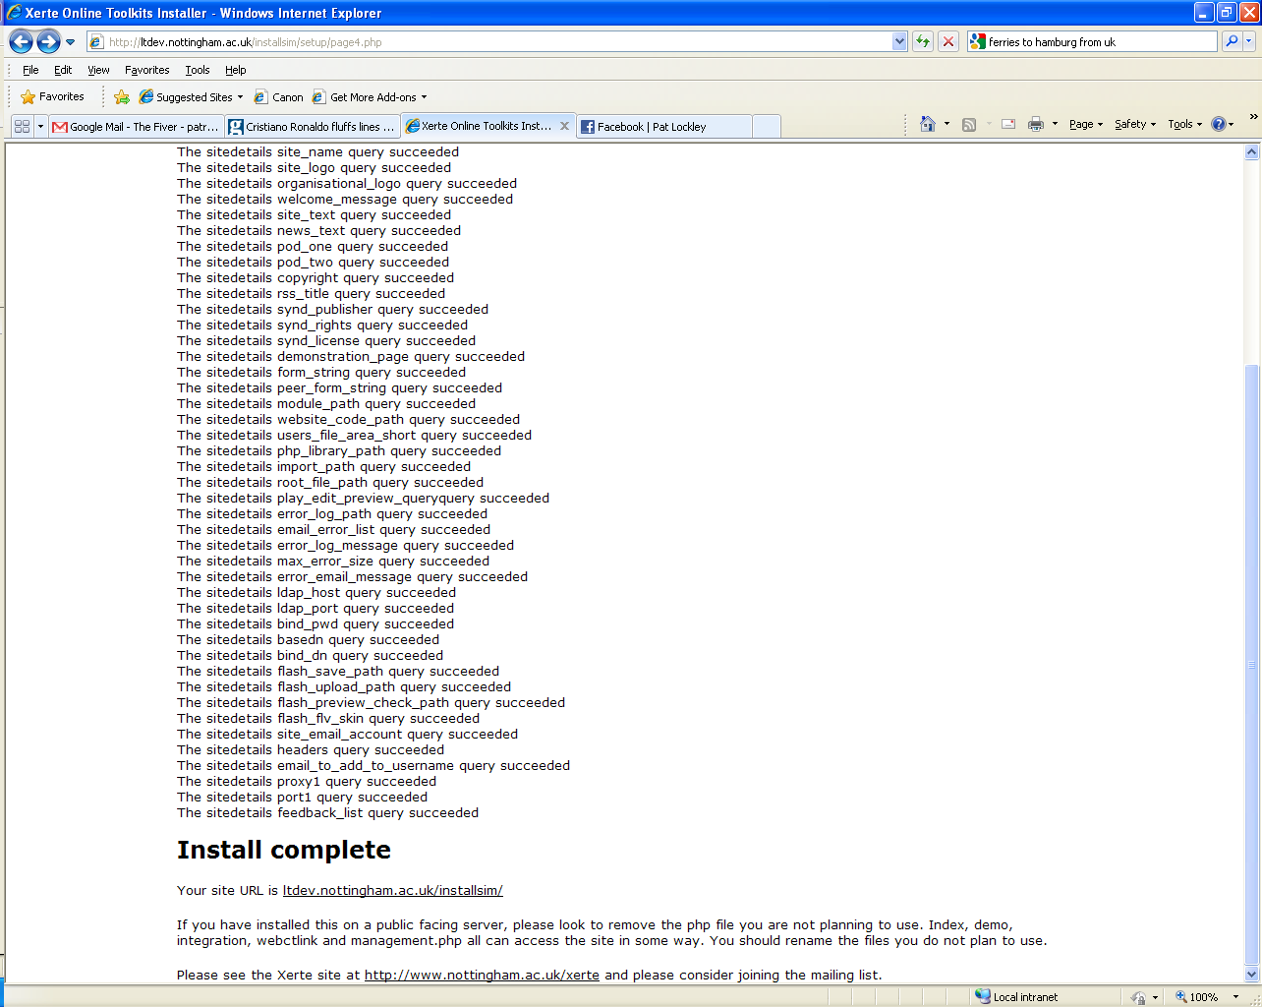

The installer runs, and provides a result for each of the values added to the system.

Any error is reported on an item per item basis.

Your site should now function normally. To change any of the values go to management.php in the root of the site.

# Authentication in Xerte Online Toolkits

Authentication in Xerte Online Toolkits comes in several forms. If you work using a local XAMPP install , then this will all be set up for you. There follows a list of authentication options:

Demo.txtIn the root of the install is a file called demo.txt, if you rename this to be demo.php, you will have a page which can access the site without a password or username. It is unsecure however, as it can be ran by anyone with access to the file. Do not use Demo.php on a public web server where anyone could access it unless you have other security measures in place.

Integration.txtIntegration.txt is also in the root of the install. This is like demo.php but expects to draw a password and a user name from somewhere else, such as from a moodle session or some other provider.

Webctlink.txtWebctlink.txt is an alternative to integration.txt, built specifically for WebCT version 8, and using the free powerlink available from <http://www.spvsoftwareproducts.com/>.

You need to set the powerlink up to have the following

* Pass the username via GET as “username”
* Pass the a variable called “webctpowerlink” and set it as “true”

Then alter line 70 of webctlink.txt so that ***YOURWEBSITEHERE*** is the name of your webct host. Then rename webctlink.txt to be <<something>>.php and add this url into your powerlink configuration.

Switch.txtSwitch.txt is the same as demo.txt except is has limited support for multiple users. It is not considered suitable for enterprise level usage.

Lines 116-120 of Switch.txt provide examples of how the system authenticates. Taking line 116 as an example

case "pat": if($_POST["password"]=="patpassword"){ $authenticated = true; set_user_details("Pat","Blair");}; break;

This will provide for you a user called pat, with the password “patpassword”. Pat’s first name is also Pat, and Pat’s surname is Blair.

So to set up an account for Joe Bloggs, with the password “opensesame”, it would look like

case "joe": if($_POST["password"]=="opensesame"){ $authenticated = true; set_user_details("Joe","Bloggs");}; break;

Running Xerte Online Toolkits with Authentication from MoodleRon Mitchell has created a patch to allow Moodle users to use Moodle to authenticate users to Xerte Online Toolkits. The patch can be downloaded from <http://mitchellmedia.co.uk/xerte/xerte_1.0.2_moodlepatch.zip>

# Frequently Asked Questions

Q: When I extract the zip file, I receive a lot of duplicate error messages  
A: Make sure that when you unzip, your zip tool ensures the folders are unzipped as well

Q: I get “Page cannot be found” when I try to run setup  
A: You may have another web service running. If you are running a PC, try this guide to disabling IIS - <http://support.microsoft.com/kb/321141>. Only disable IIS if you are certain no other service on your PC uses it. You also need to make sure PHP is running. If your using XAMPP, look at the XAMPP control panel to see if PHP is running.

Q: I get a function “Mysql_connect” does not exist error  
A: You do not have MySQL installed as a PHP module. Install mysql (perhaps using XAMPP) then start again. You need to make sure MySQL is running. If your using XAMPP, look at the XAMPP control panel to see if MySQL is running

Q: On page 4 of the installer I get a series of errors.  
A: You did not make the root folder and/or the setup of your site writable too. As such your database configuration will not have been set up. You will need to start the process again after making the folders writable. You specified the wrong database host and / or password. The account you gave on page 2 lacks insert rights to this database

Q: When I try to log in I get a white screen  
A: You do not have LDAP installed. If you cannot use LDAP to authenticate, consider using one of the other options provided in the authentication section.

Q: I cannot log in as administrator  
A: The administrator account only works on management.php, not index.php  
A: You did not set admin_username and admin_password when setting up the site

Q: I get the following error:  
“Warning: fopen(database.txt) [function.fopen]: failed to open stream:

Permission denied in

/home/httpd/vhosts/schoolict.ch/httpdocs/xertetoolkits/setup/page2.php

on line 98

Warning: fwrite(): supplied argument is not a valid stream resource in

/home/httpd/vhosts/schoolict.ch/httpdocs/xertetoolkits/setup/page2.php

on line 99

Warning: fclose(): supplied argument is not a valid stream resource in

/home/httpd/vhosts/schoolict.ch/httpdocs/xertetoolkits/setup/page2.php

on line 100”

A: You did not set the setup folder to be writable. Restart the process after making this change

Q: The RSS page doesn’t work

A: You need to set a proxy and a proxy port in the management side of things for this to work

Q: When I create a new piece, the editor buttons are greyed out and disabled  
A: You may need to set up new mime types on your server.   
A: Your learning object failed to load – is the USER-FILES folder empty?

Q: I can’t create new items – they only display when I refresh a page  
A: Something in your PHP code is failing, check the sitedetails table to see if root_file_path is ok, or that you have right access to the user-files folder.

Q: None of the play, edit or preview pages work  
A: You may have set up a .htaccess when you can’t use one, or your Apache server has other settings conflicting with the .htaccess used by Xerte Online Toolkits

# Site Management

Managing a Xerte Online Toolkits install can be achieved by using management.php. This is another web based interface stored in the root folder of the install. This feature doesn’t work on standard XAMPP Installs. You will need to set admin_username and admin_password in the sitedetails table for this feature to work properly

Then visit either http://yoursite/management or http://yoursite/management.php to access these panels.

## Using Management.php

### The Main Panel: Site

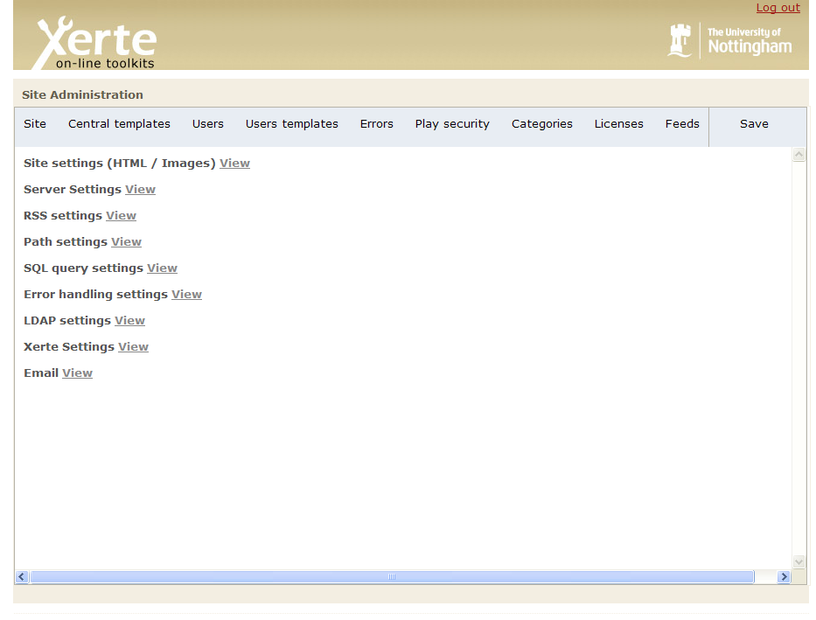

The main panel replicates the functionality of the installer. Here you can click on view, and then you will see the settings relevant to that area.

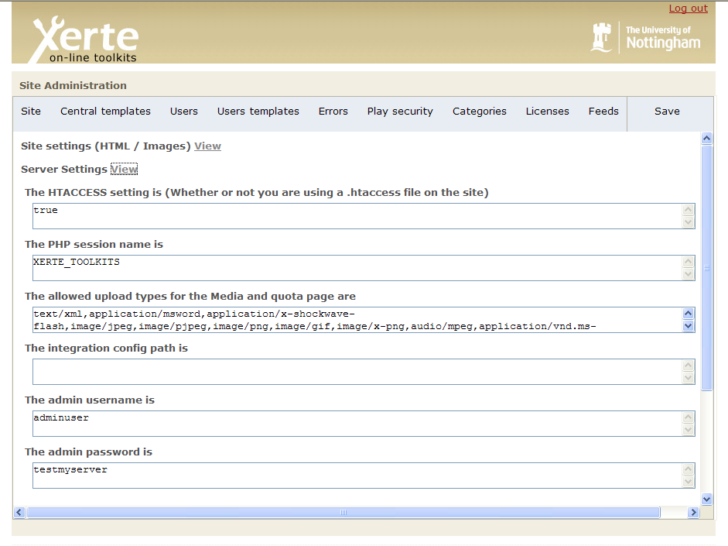

You can then change these and then click on “save” in the top right.

You can see a full list and explanation of what these values do earlier in this document.

### Controlling What Templates Are Available: Central templates

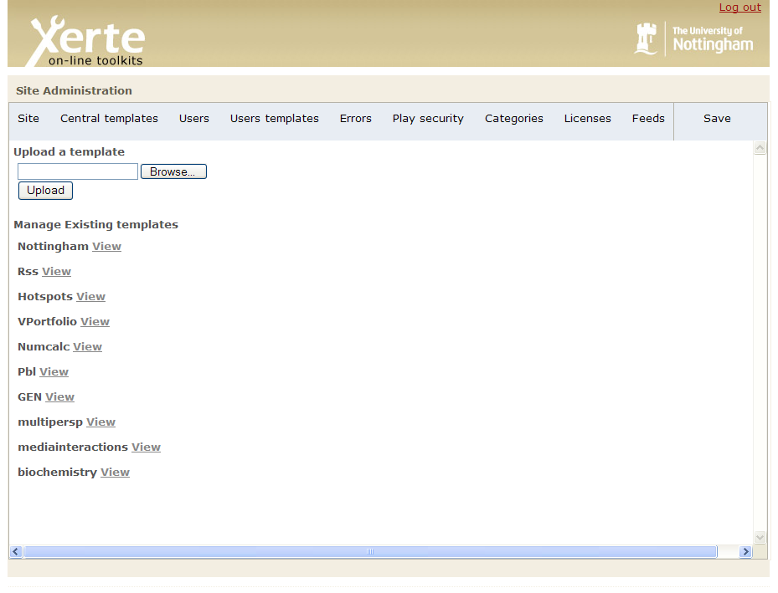

Clicking on central templates will bring up the following. Here you can see all of the templates currently installed on the site.

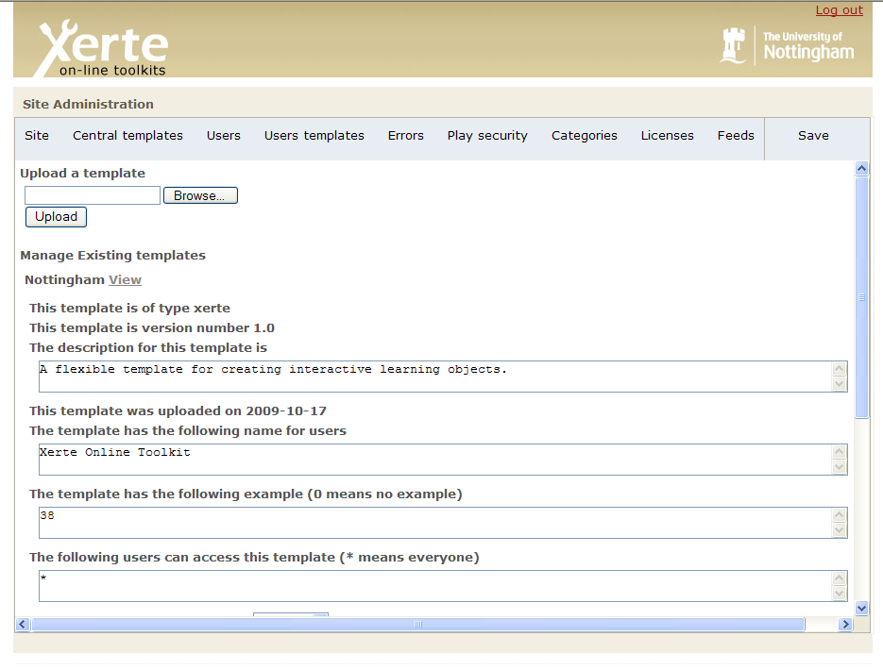

Clicking on view will bring up template details including

1)Module type for this template

2)Version number

3)Template description

4)Template name

5)Template example number

6)Template access restrictions (who can access this template)

7)Whether this template is active

These values can be changed and saved by clicking on upload – you can also use this feature to upload new templates, or replace an existing one (you cannot keep older versions backed up, this feature replaces them).

### Manager User Accounts: Users

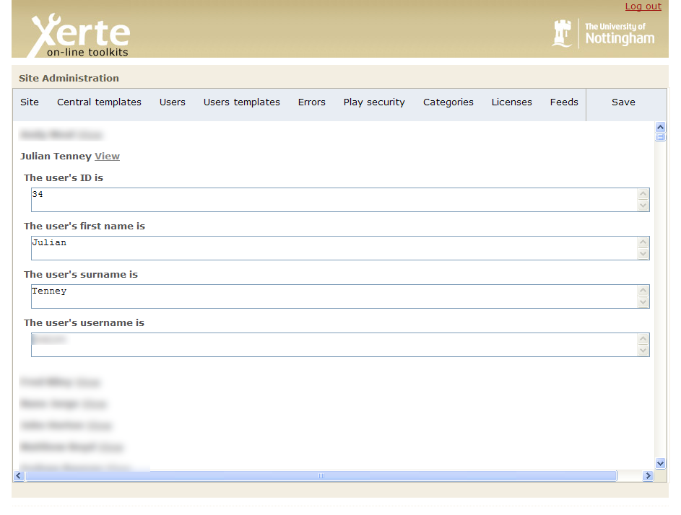

Clicking on users will bring up a list of user’s who have used the site. Clicking on view will bring up their details. You could use these tools for changing a users name or moving content from one user to another.

### Managing User Projects: Users templates

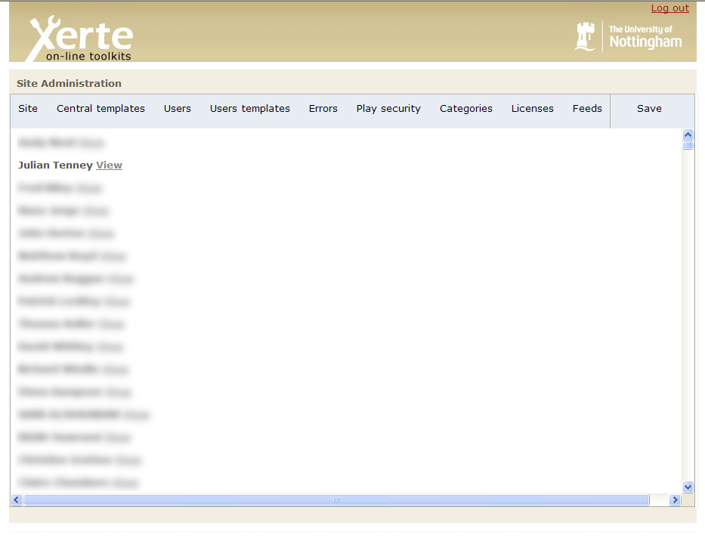

Clicking on user templates will bring up the following screen, and then you can click on view so you can see an individual users projects

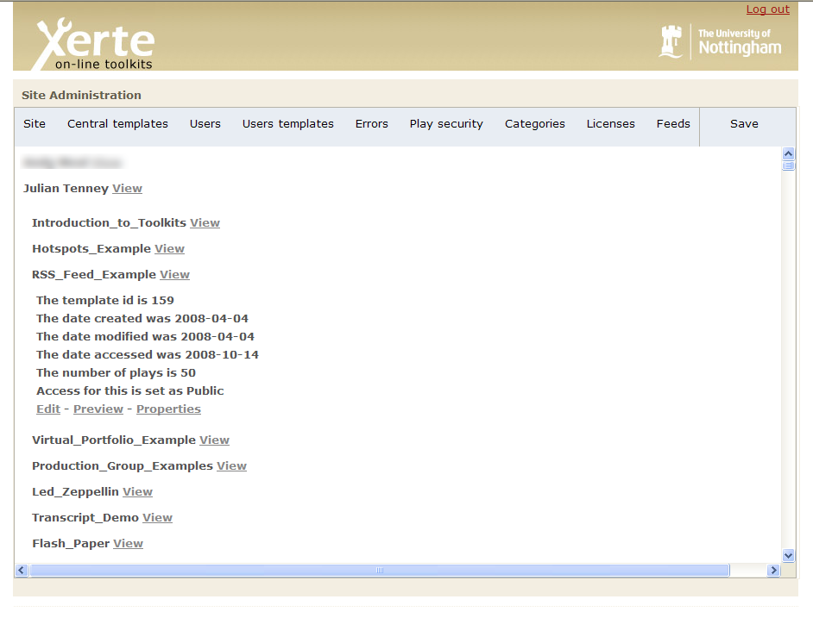

Then click on view to see that particular projects – details. Here you can (as adminiatrator) edit these templates and also look at properties.

### Tracing Site Activity: Errors

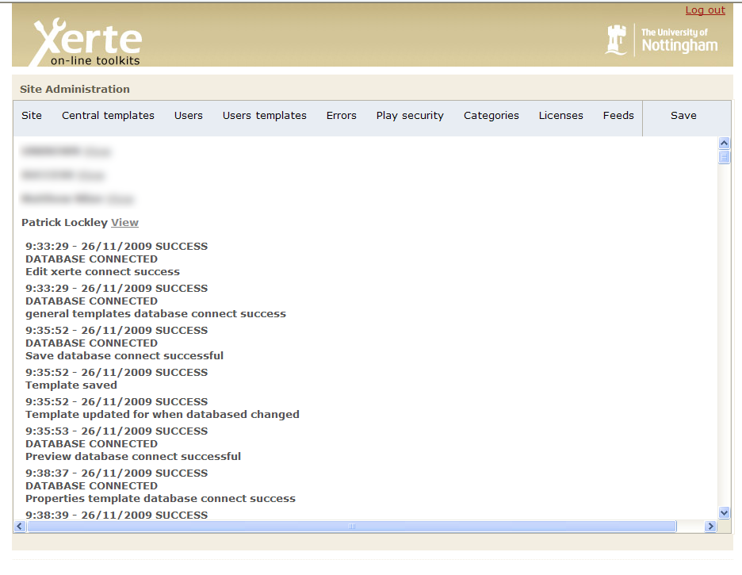

If you have turned error logs on, this screen will display the logs for each user. Click on view next to a user and you will see what the site has recently logged for them.

### Setting New Security Options: Play Security

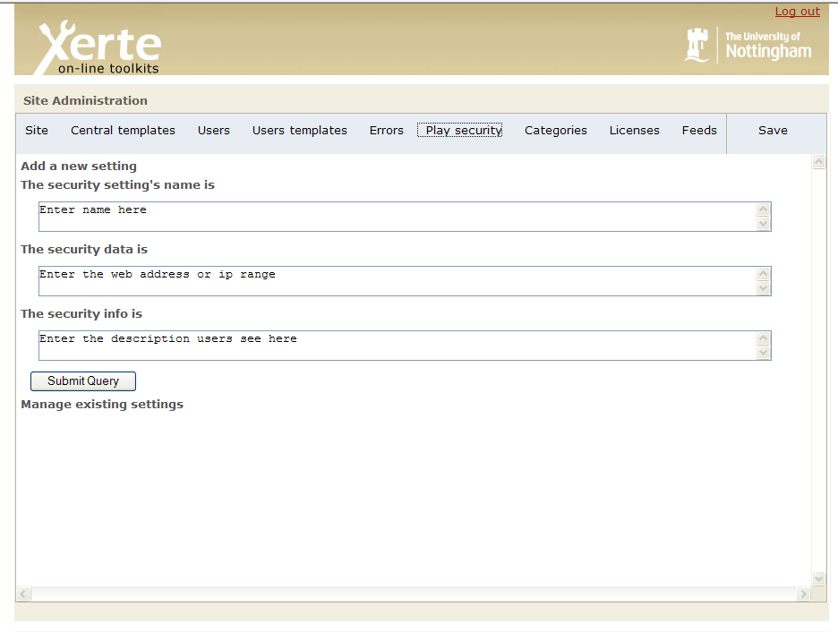

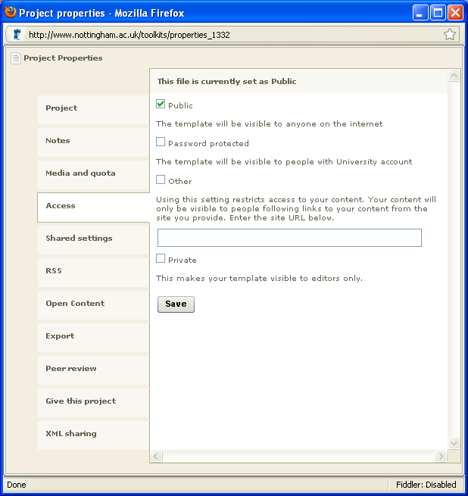

On the access tab in properties, you can see a list of possible access options. On this part on the management screen you can add new options.

The name is what is put next to the tick box, the data is either a colon separated list of web addresses (taken from server referrer) or ip addresses (taken from remote host) and the info is the small paragraph underneath the name.

**RSS options – “Categories”**

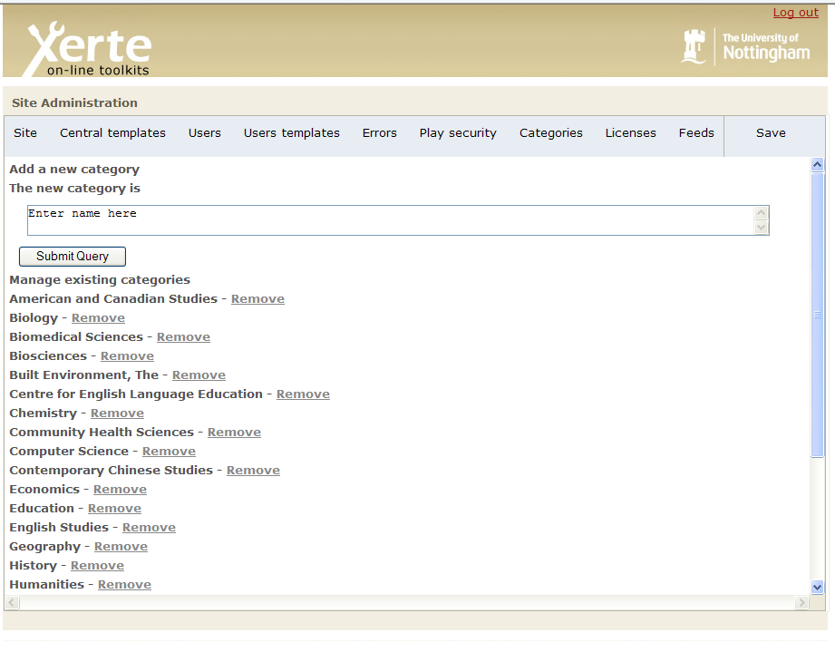

If you want to add or remove a new option for RSS categories, come to this page, and either type a new one in and click “submit query” or click on one you would like to remove.

### RSS Options: Licenses

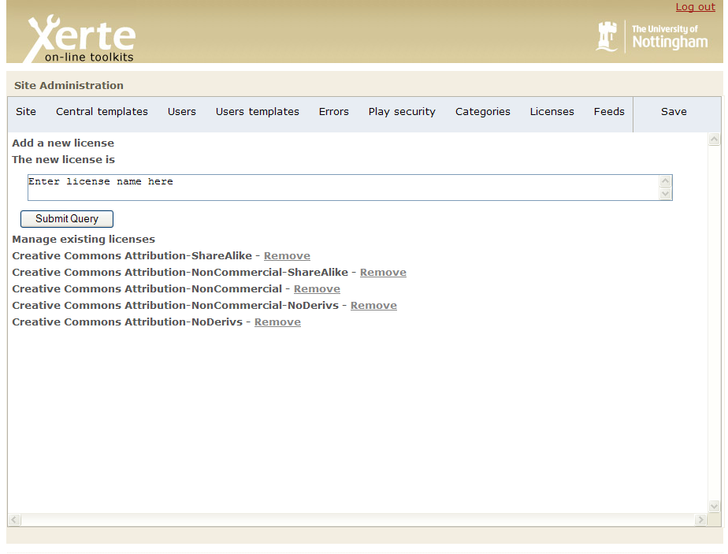

As well as categories, items submitted to an RSS feed should have rights for reuse attributed to them. This page allows you to add new or remove licenses you do not need.

### RSS Options: Feeds

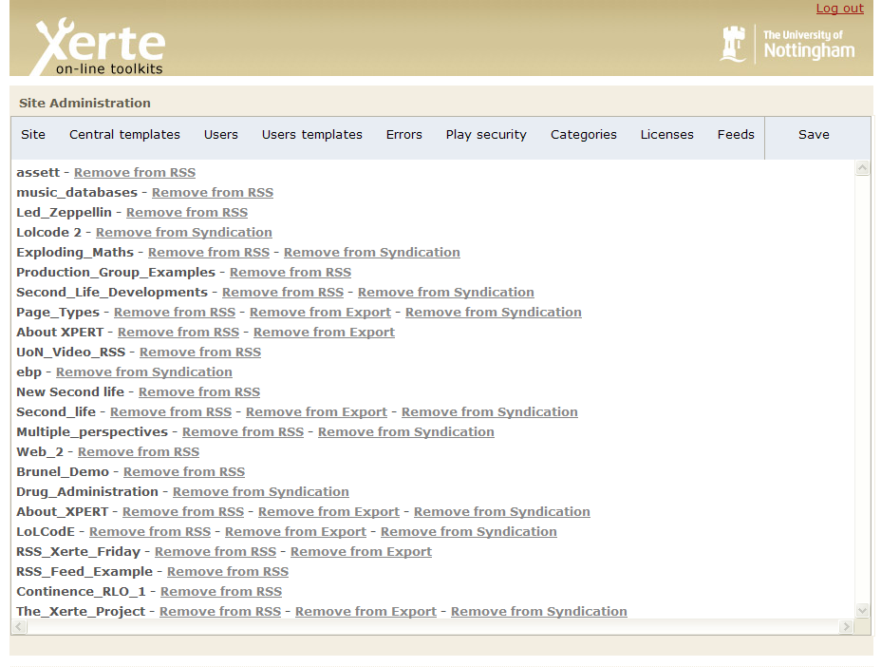

You may also find content in your feed which is not suitable. This page allows you to remove items from the three feeds (RSS, Export and Syndication) that Xerte Online Toolkits supports.